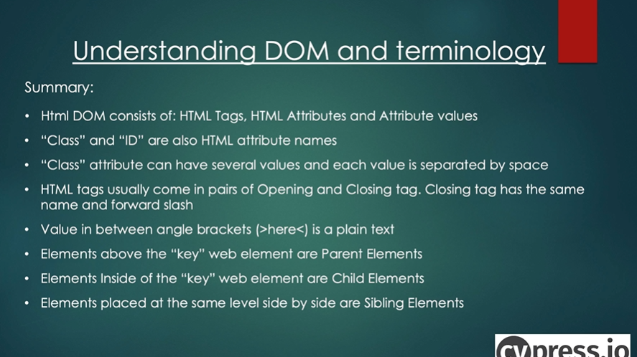

- HTML Tag Name -> div (in pairs with open and close tag), input

- HTML Attribute Name -> data-cy, id, type,class etc.. they can have values, class can have multople values or different classes

- opening tag -> tbody, tr,td (able row and body), they have text values, tr is the key element, all above it are parent elements, child elements are inside of tr,

sibling elements are elements located in the same stucture like td and tr

/// <reference types="cypress" />

It gives us hints about the cypress library

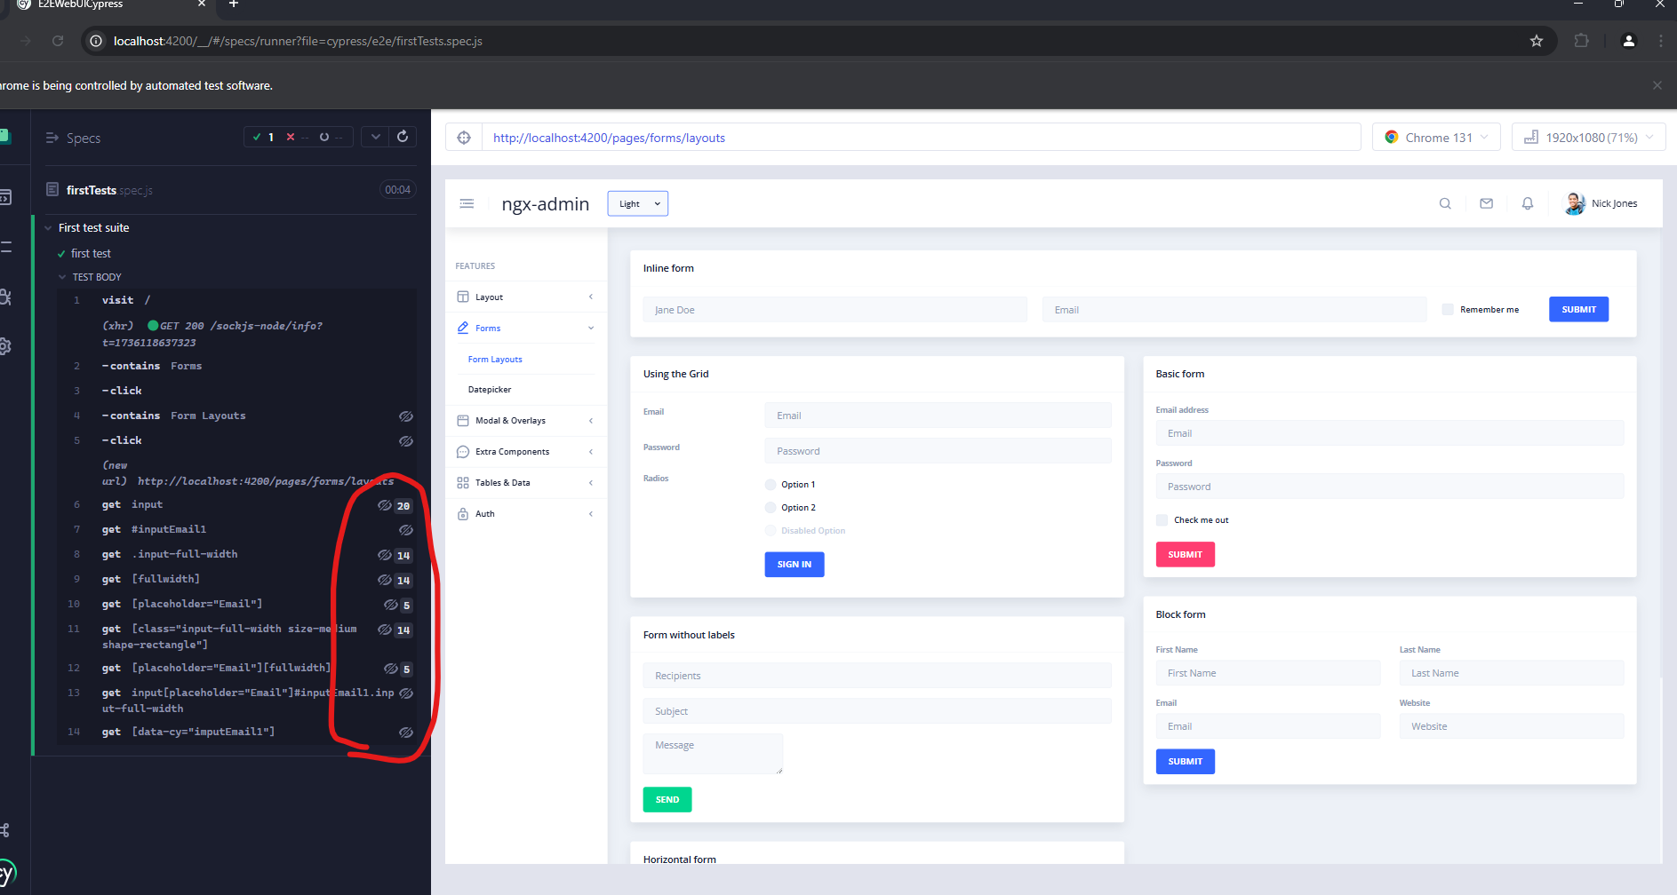

How many of them are available. If you want xpath you need to install xpath

To check the value inside go to properties tab

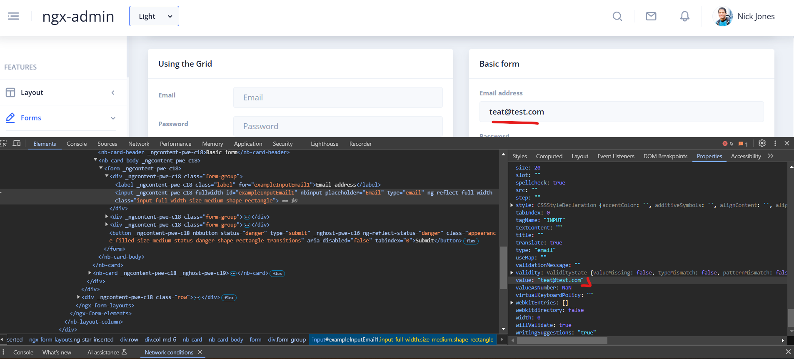

Date pickers

    it.only('Date picker', () => {

        cy.visit('/')

        cy.contains('Forms').click()

        cy.contains('Datepicker').click()

        // https://developer.mozilla.org/en-US/docs/Web/JavaScript/Reference/Global_Objects/Date

        let date = new Date()

        date.setDate(date.getDate() +5) // adding +5 days from todays date

        console.log(date)

      /*  cy.contains('nb-card','Common Datepicker').find('input').then(input =>{

            cy.wrap(input).click()

            cy.get('.day-cell').not('.bounding-month').contains('21').click()

            cy.wrap(input).invoke('prop','value').should('contain','Jan 21, 2025')

            cy.wrap(input).should('have.value','Jan 21, 2025')

        }) */

    })

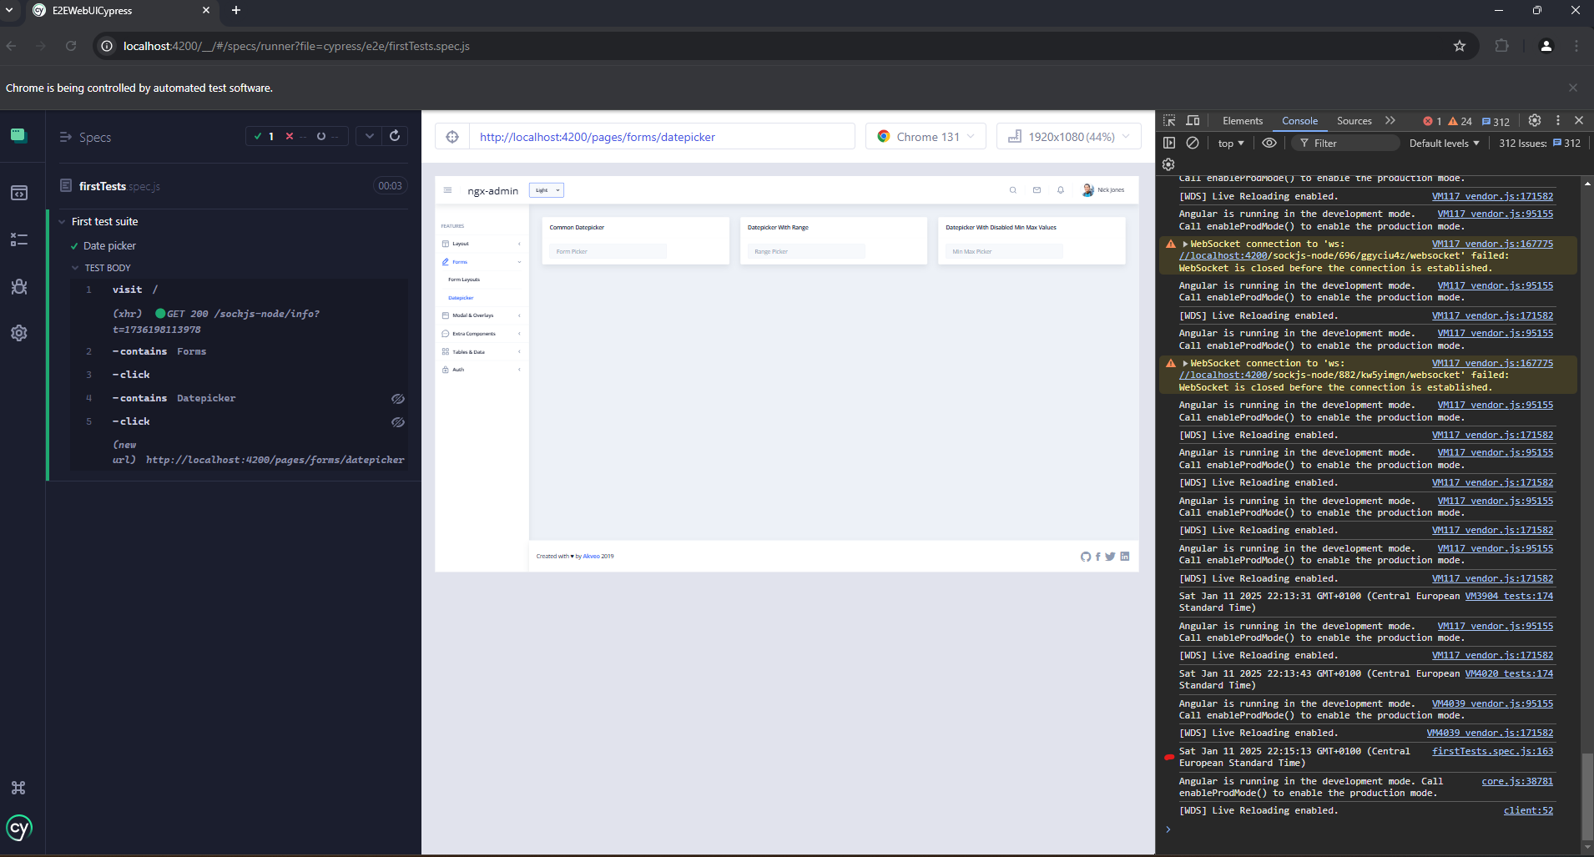

 it.only('Date picker', () => {

        cy.visit('/')

        cy.contains('Forms').click()

        cy.contains('Datepicker').click()

        // https://developer.mozilla.org/en-US/docs/Web/JavaScript/Reference/Global_Objects/Date

        let date = new Date()

        date.setDate(date.getDate() + 5) // adding +5 days from todays date

        console.log(date)

        let futureDate = date.getDate()

        let dateToAssert=`Jan ${futureDate}, 2025`

        cy.contains('nb-card', 'Common Datepicker').find('input').then(input => {

            cy.wrap(input).click()

            cy.get('.day-cell').not('.bounding-month').contains(futureDate).click()

            cy.wrap(input).invoke('prop', 'value').should('contain',dateToAssert)

            cy.wrap(input).should('have.value', dateToAssert)

        })

    })

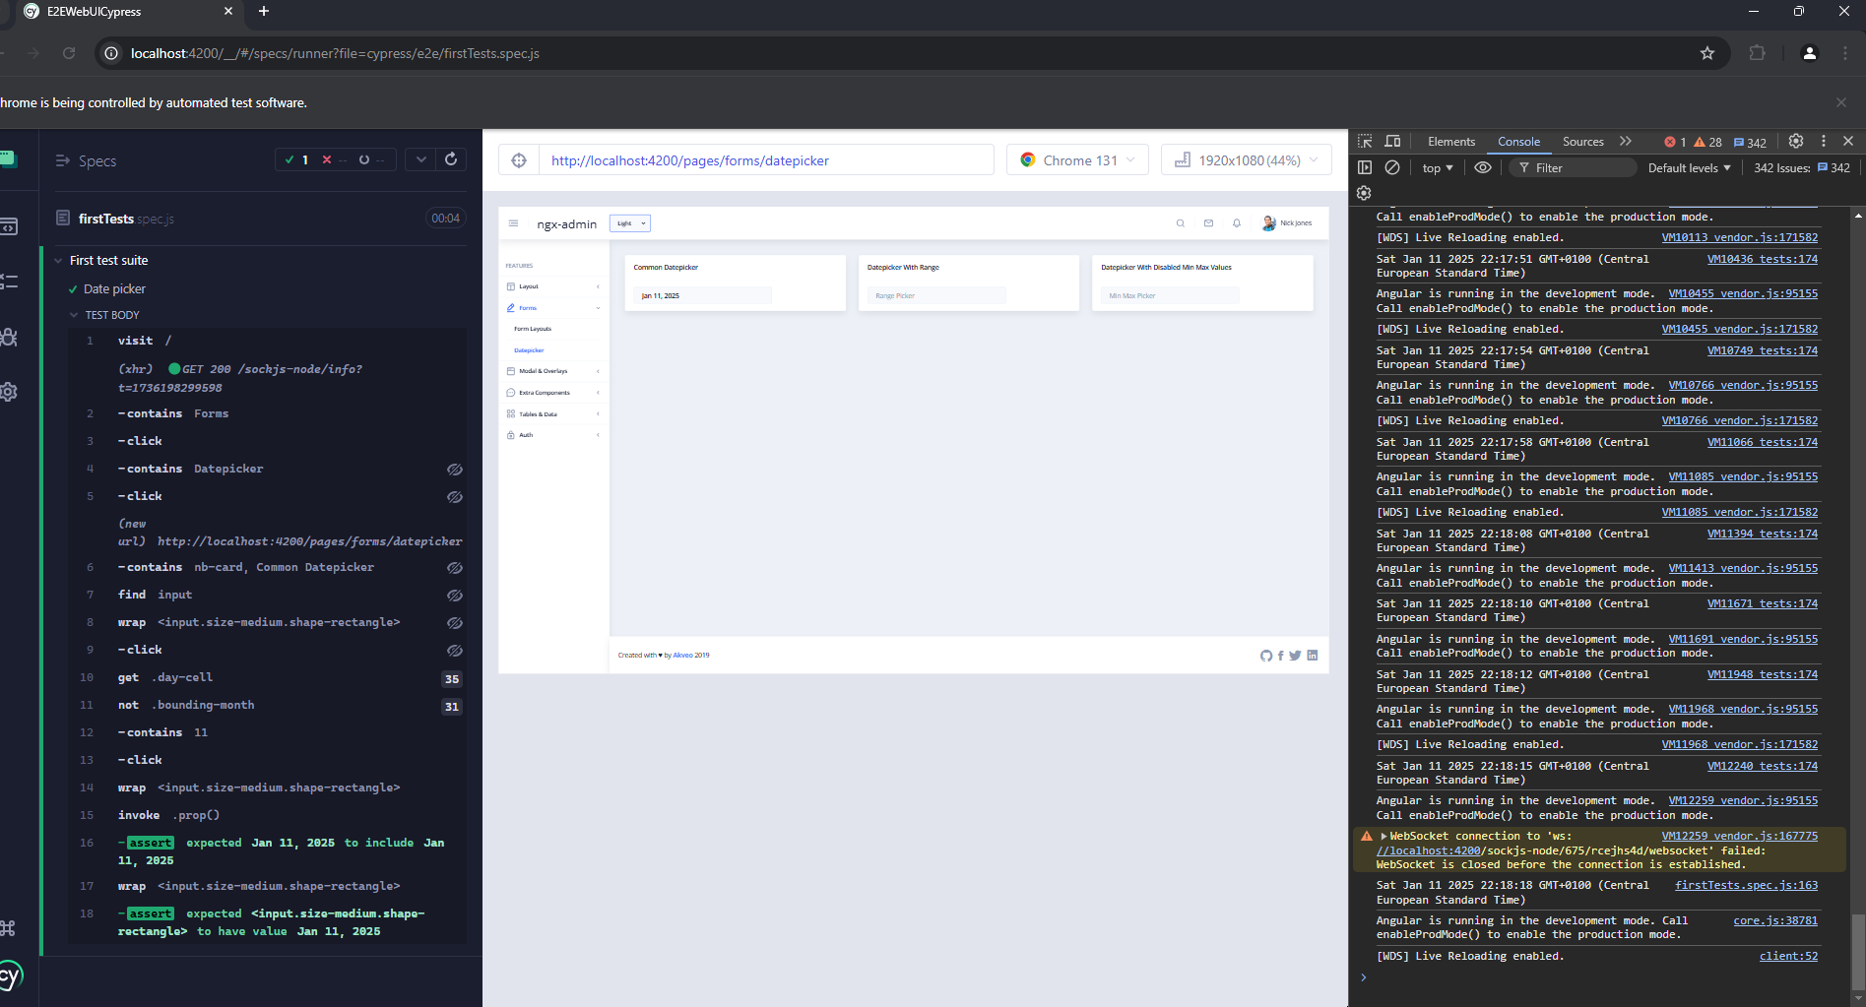

The calendar does not change the month if we add plus 30 days from today

Json objects

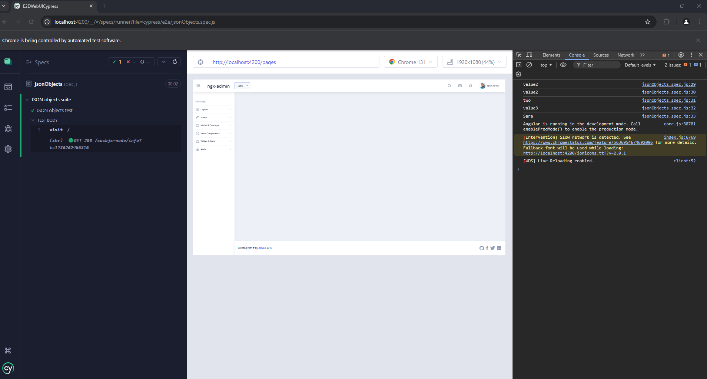

Api storage of token for the app

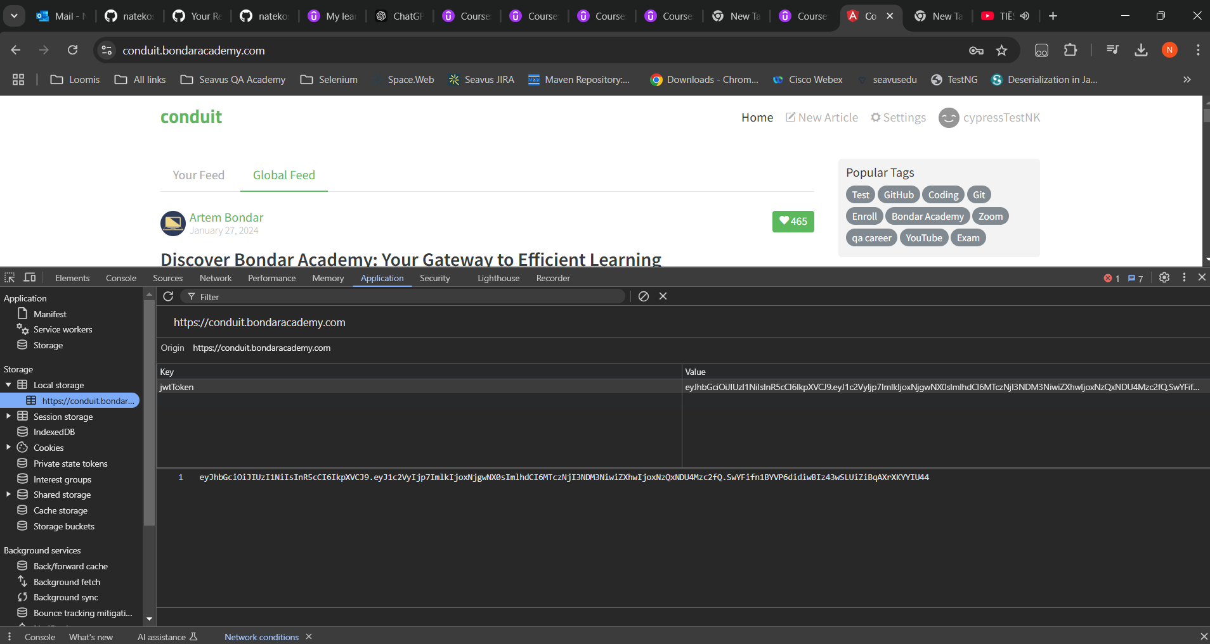

**RUN TESTS IN HEADLESS MODE**

Terminal -> npx cypress run

**If you want only on one browser (the browser will be closed after the test is finished)**

npx cypress run --browser chrome

**If you want to run only one file i.e**

npx cypress run --spec "cypress\e2e\firstTests.spec.js"

**If we want to start the application**

ng serve or npm start

<https://docs.cypress.io/app/references/command-line>

**add this in package.json scripts**

"cypress:run":"npx cypress run"

And run in terminal npm run cypress:run

-----------------------------------------------------------------------------------------------------------------------------

**Lets say we want to have just one script to serve our app and run our test**

<https://www.npmjs.com/package/start-server-and-test>

npm install --save-dev start-server-and-test

**add this in package.json scripts**

"cypress:e2e":"start-test start http-get://localhost:4200 cypress:run"

**Will start the application and run our tests**

npm run cypress:e2e

adding env parameters in cypress.config.file

<https://docs.cypress.io/app/references/environment-variables>

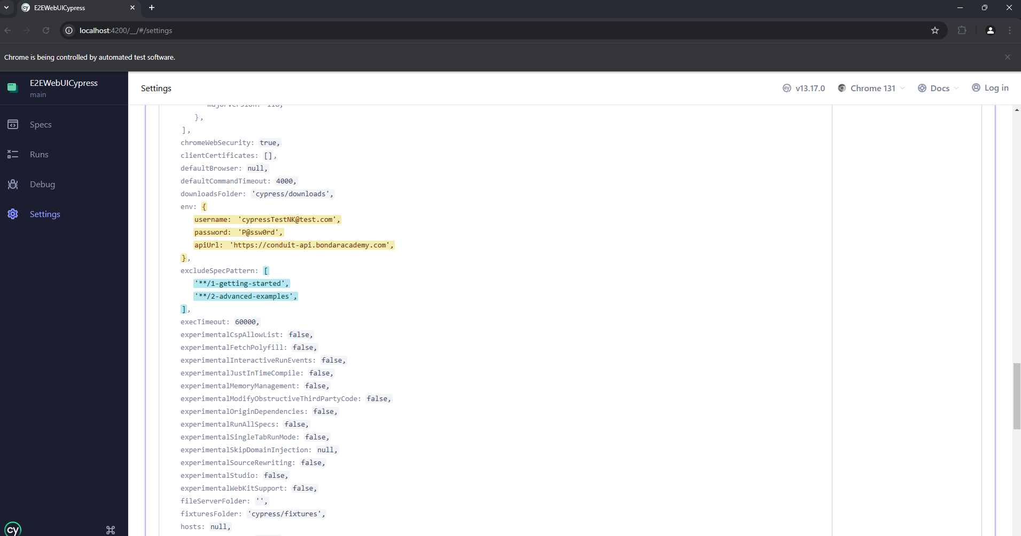

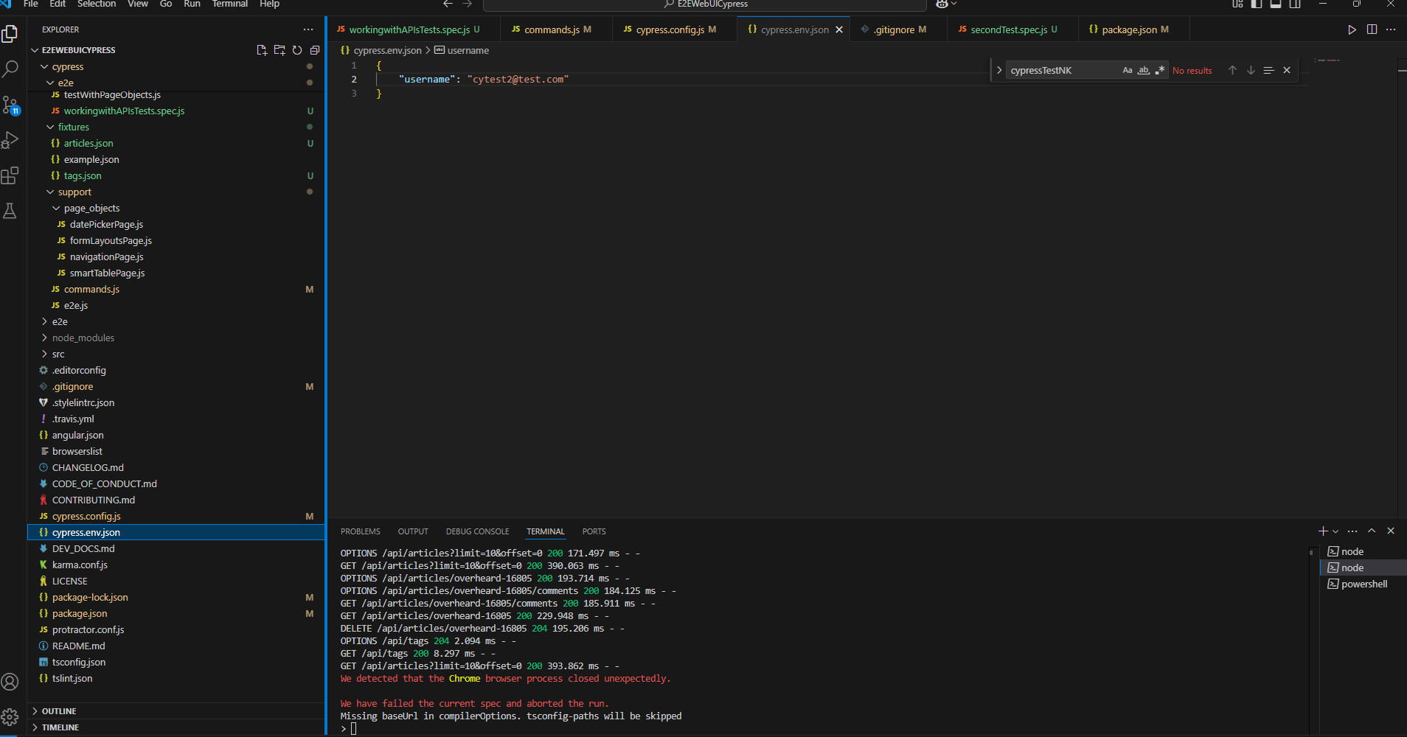

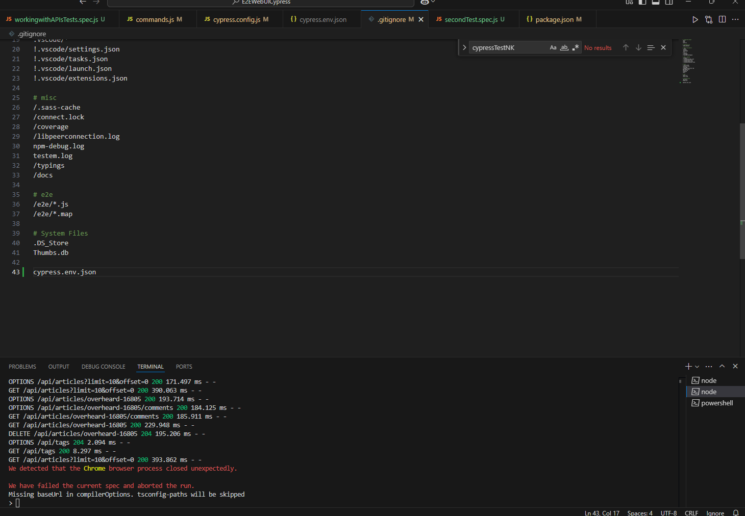

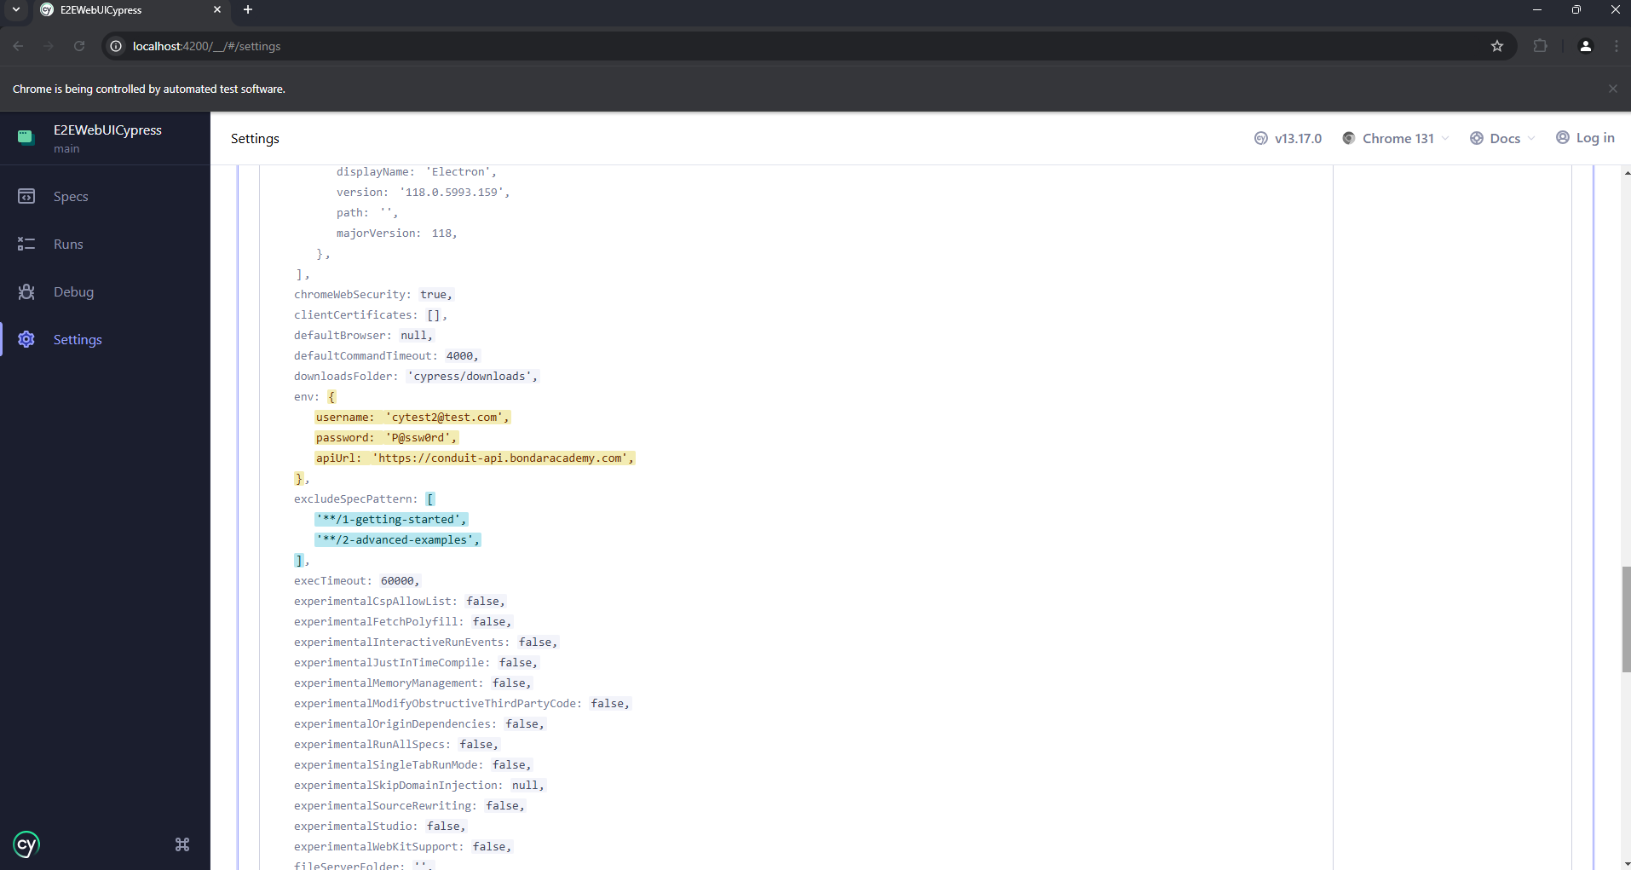

**Through terminal npx cypress open --env** [**username=cytest3@test.com,password=Welcome567**](mailto:username=cytest3@test.com,password=Welcome567)

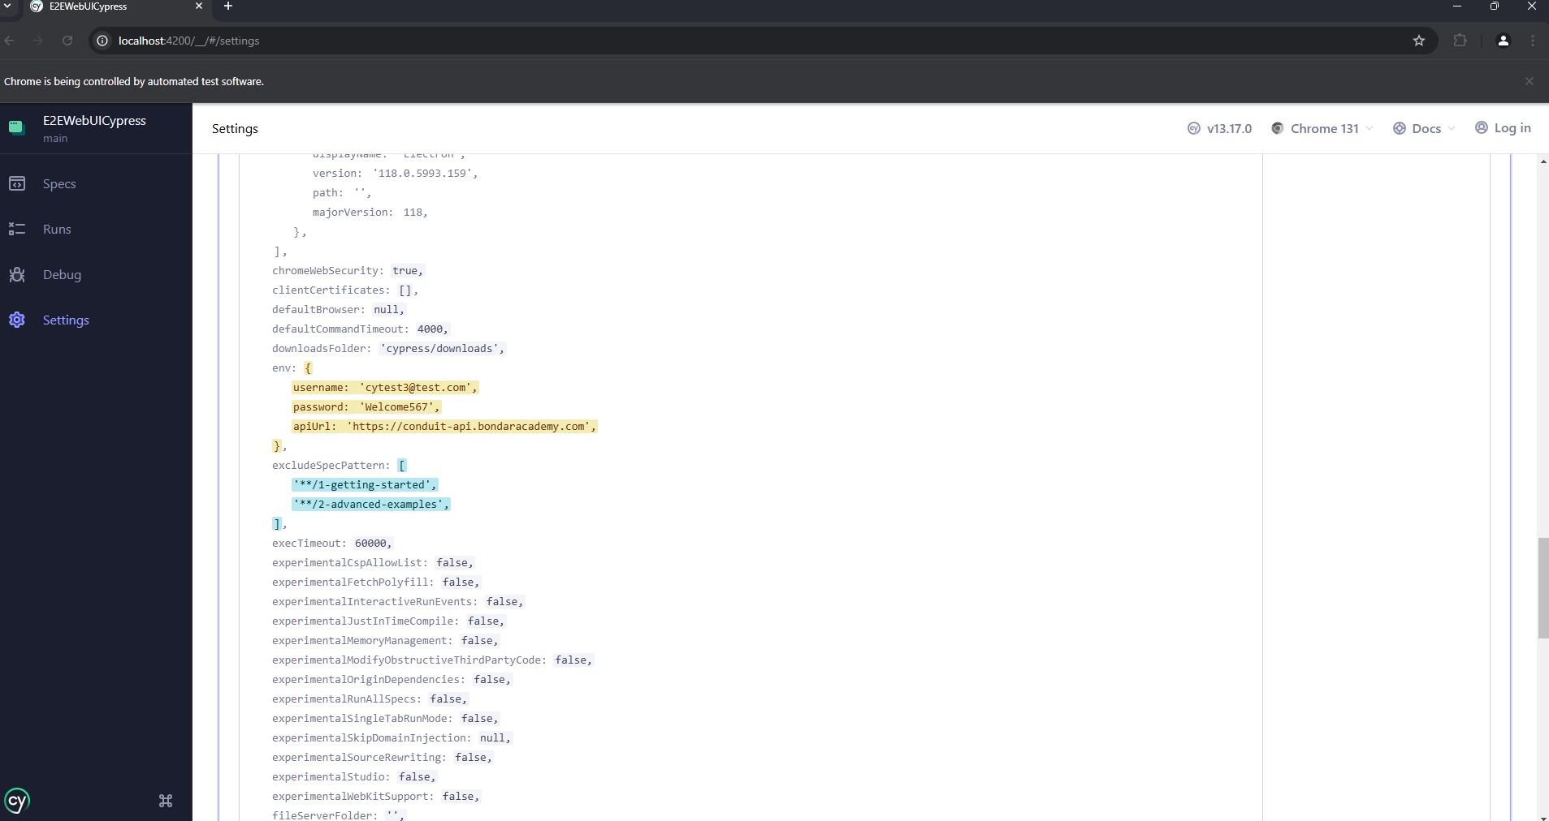

 "cy:open_dev":"npx cypress open --env username=cytest3@test.com,password=Welcome000",

    "cy:open_qa":"npx cypress open --env username=cytest4@test.com,password=Welcome999"

**npm run cy:open_dev**

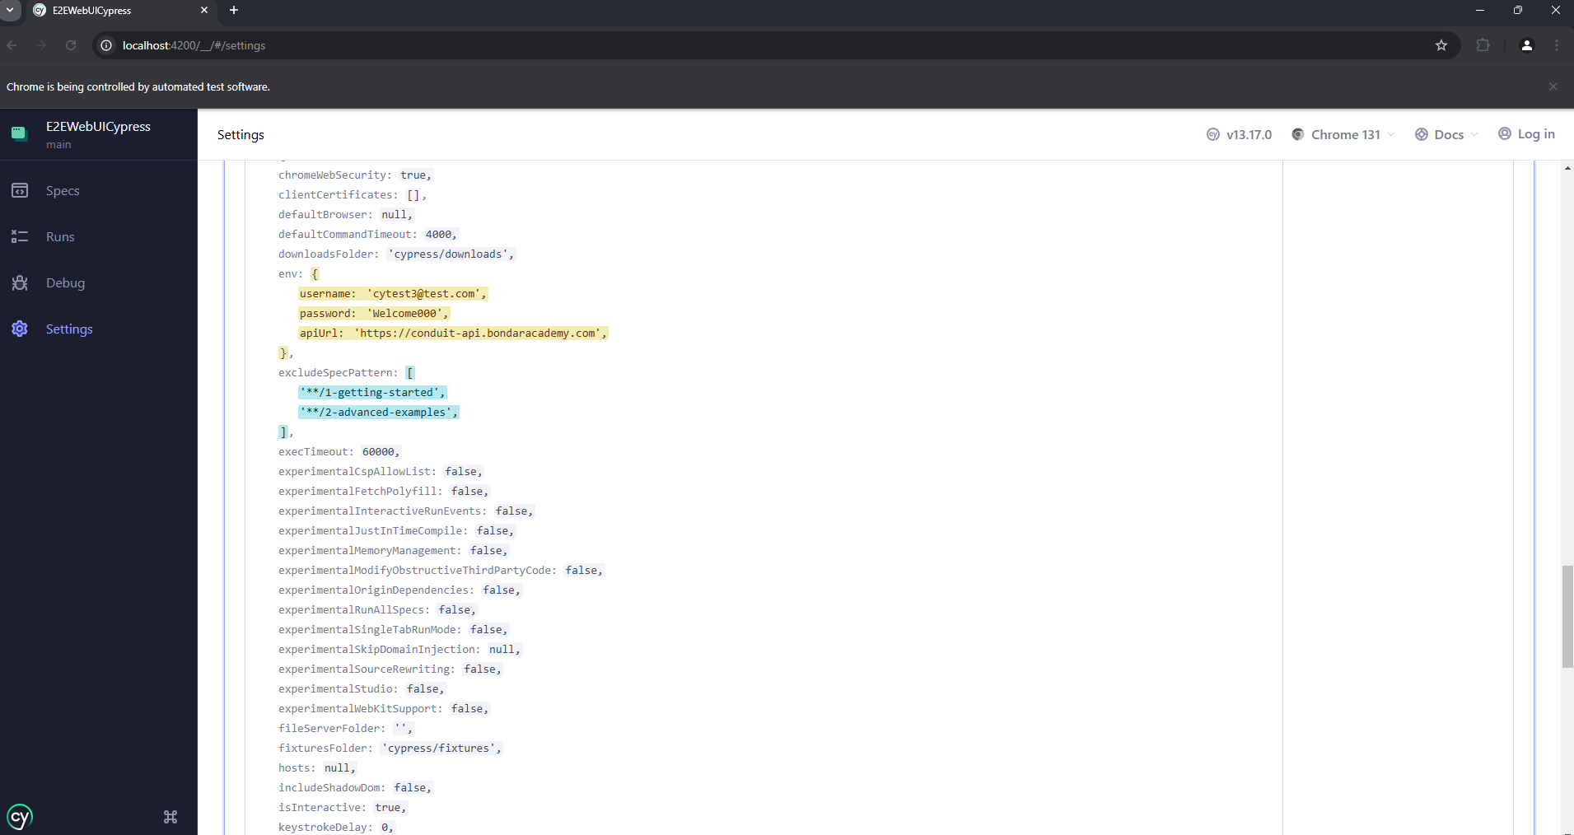

**npm run cy:open_qa**

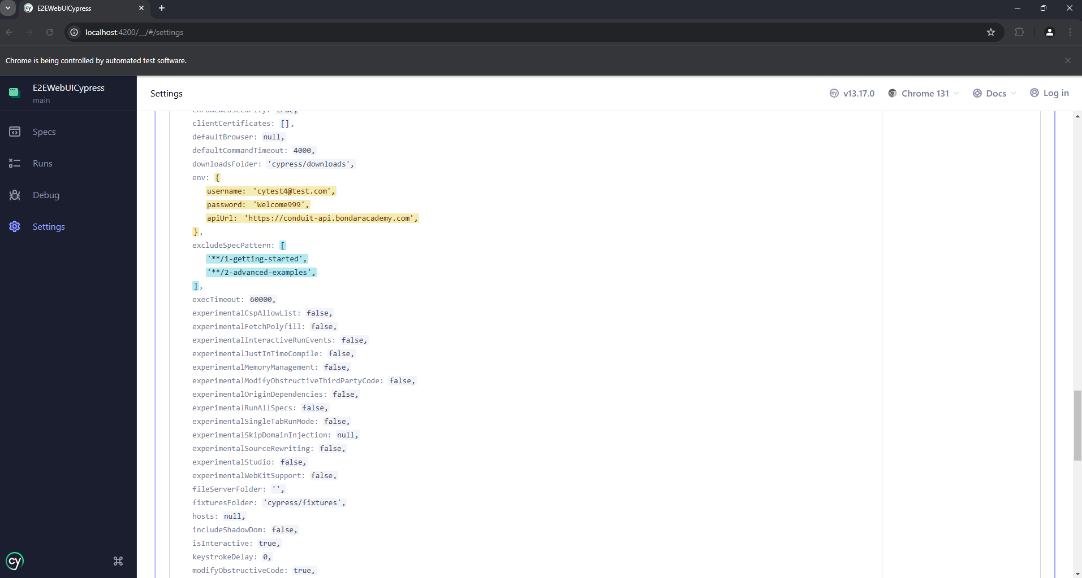

"cy:open_process":"npx cypress open --env username=$DB_USERNAME,password=$PASSWORD"

setupNodeEvents(on, config) {

      const username = process.env.DB_USERNAME

      const password=process.env.PASSWORD

      if(!password){

        throw new Error('missing PASSWORD environment variable')

      }

      config.env={username,password}

      return config

    },

**$env:DB_USERNAME="cytest2@test.com"; $env:PASSWORD="Welcome123"; npm run cy:open_process**

**This below only for linux and mac**

**DB_USERNAME=”**[**cytest2@test.com**](mailto:cytest2@test.com)**” PASSWORD=”Welcome123” npm run cy:open_process**

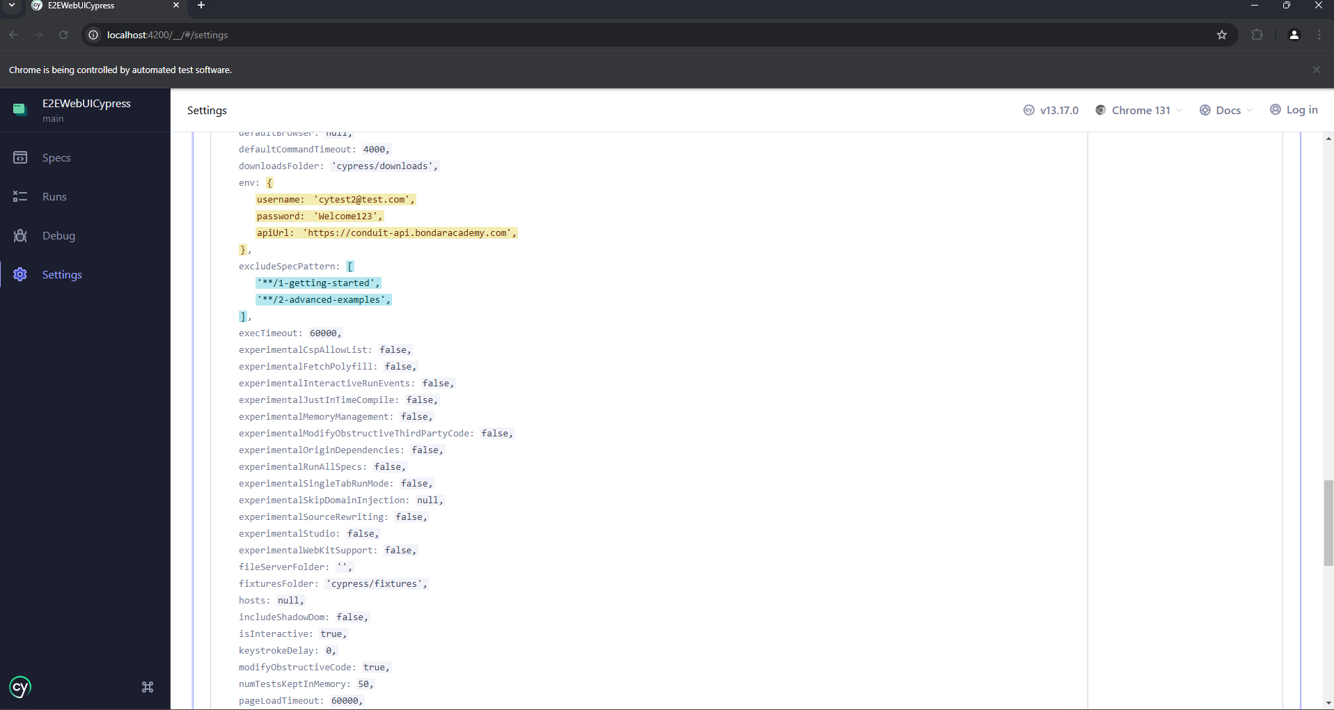

env: {

    username: 'cypressTestNK@test.com',

    password: '',

    apiUrl:'https://conduit-api.bondaracademy.com'

  },

**$env:DB_USERNAME="cypressTestNK@test.com"; $env:PASSWORD="P@ssw0rd"; npm run cy:open_process**

**So the tests can work**

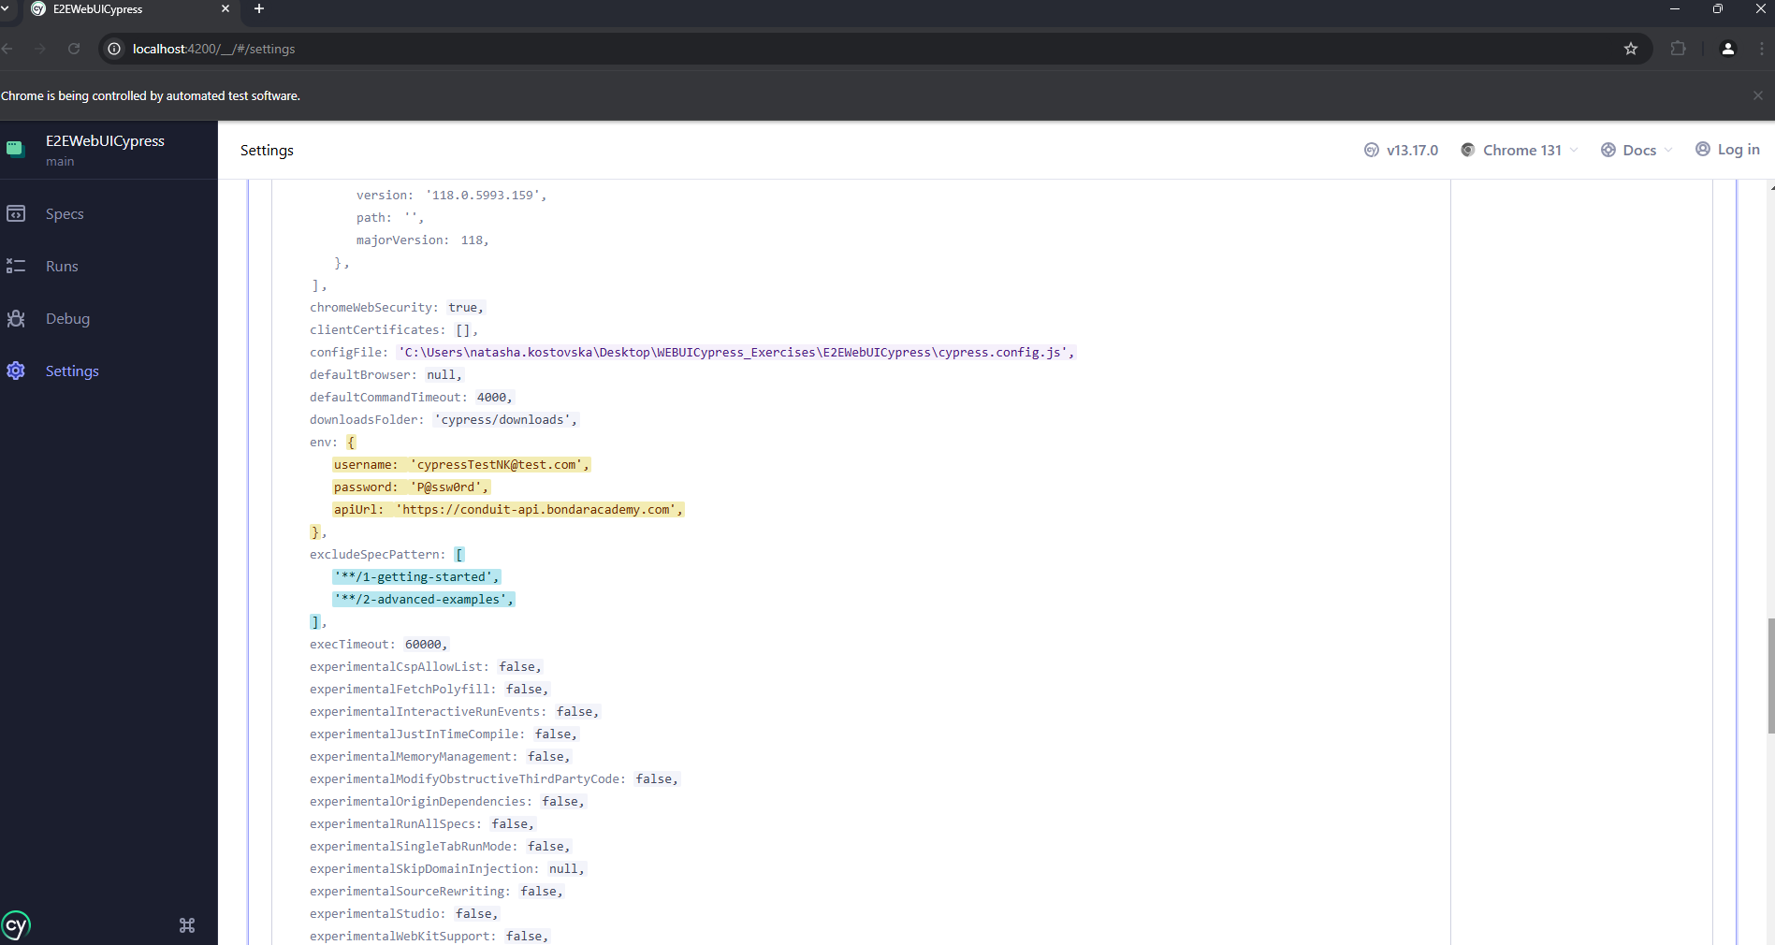

[**https://docs.cypress.io/app/guides/test-retries**](https://docs.cypress.io/app/guides/test-retries)

**cypress.config**

retries:1,

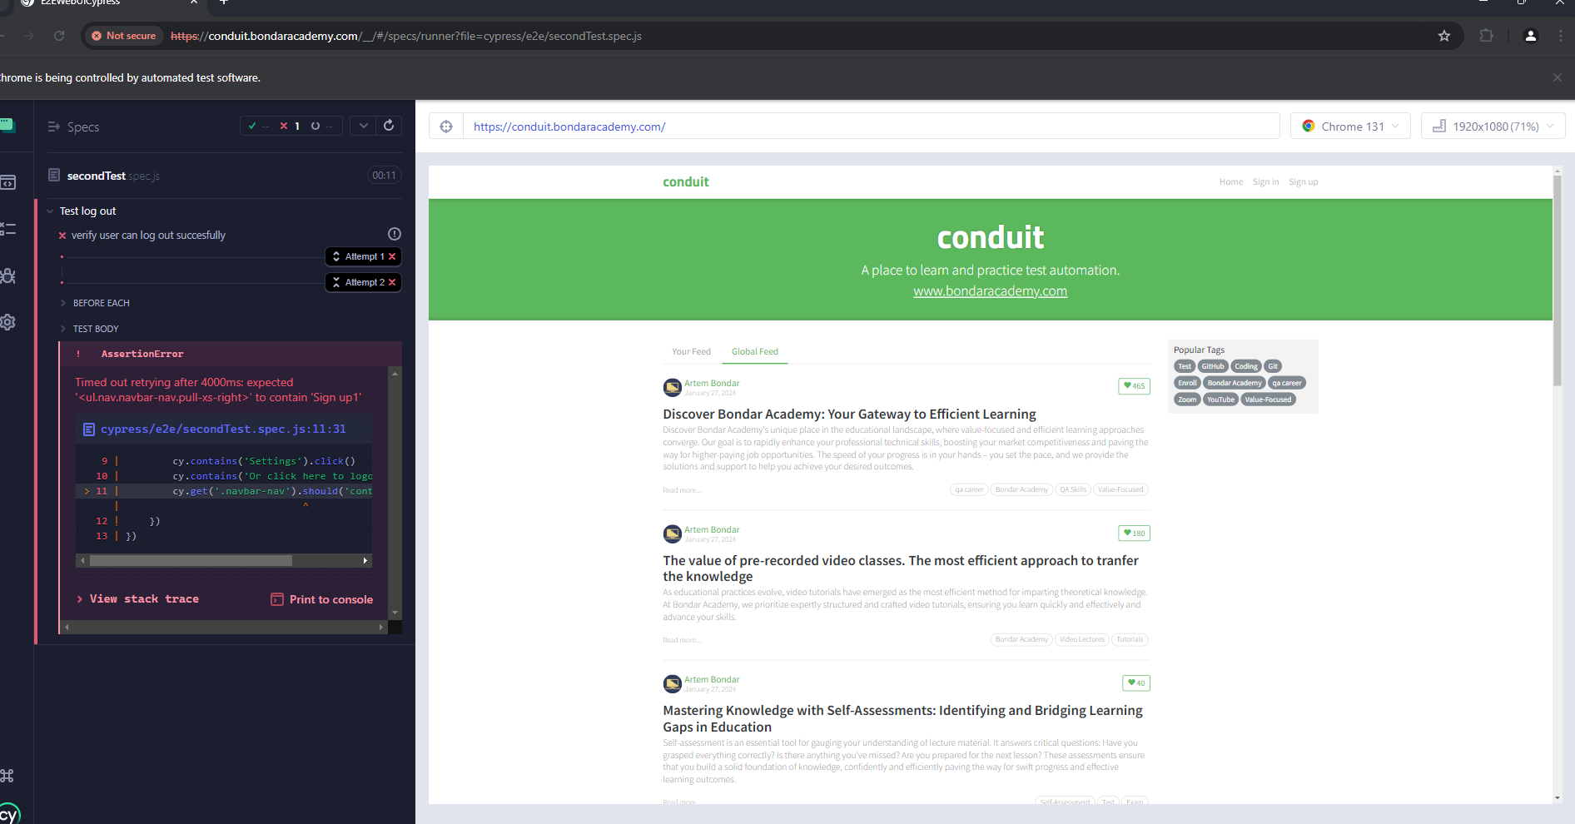

describe('Test log out', () => {

    beforeEach('log to app', () => {

        cy.loginToApplication()

    })

    it('verify user can log out succesfully', () => {

        cy.contains('Settings').click()

        cy.contains('Or click here to logout').click()

        cy.get('.navbar-nav').should('contain','Sign up1')

    })

})

**cypress.config**

  retries: {

    runMode: 2,

    openMode: 0

  },

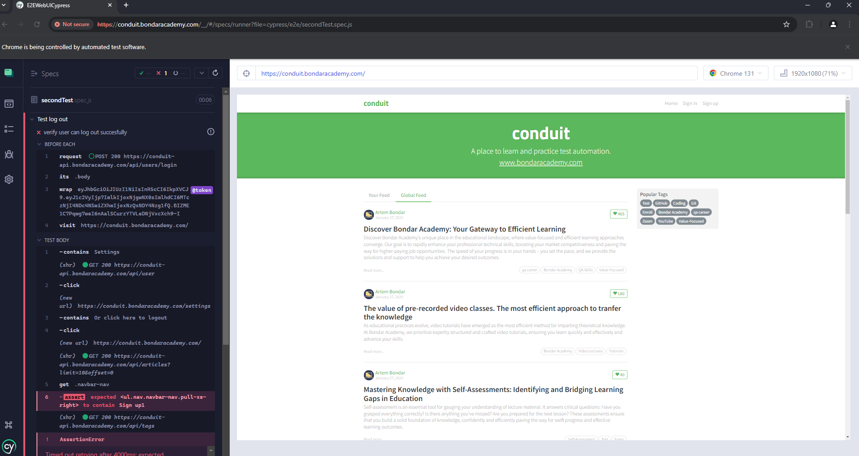

**npx cypress run --spec 'cypress\e2e\secondTest.spec.js'**

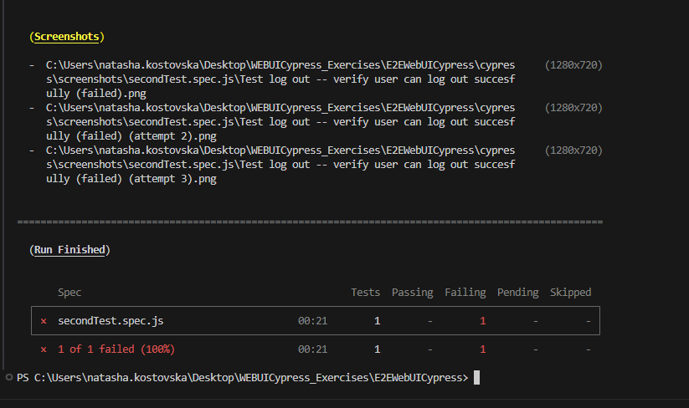

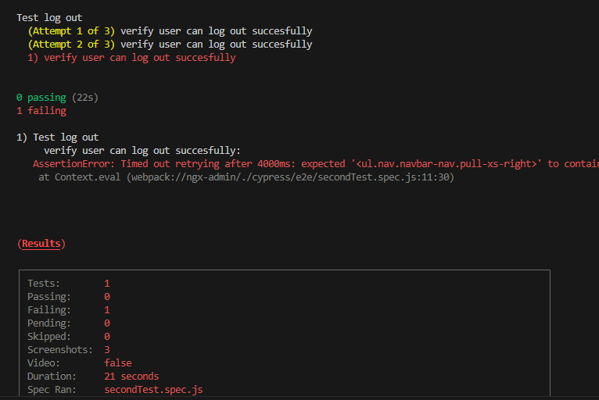

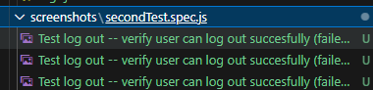

**Want specified test to be retried**

 it('verify user can log out succesfully', {retries:2}, () => {

        cy.contains('Settings').click()

        cy.contains('Or click here to logout').click()

        cy.get('.navbar-nav').should('contain','Sign up1')

    })

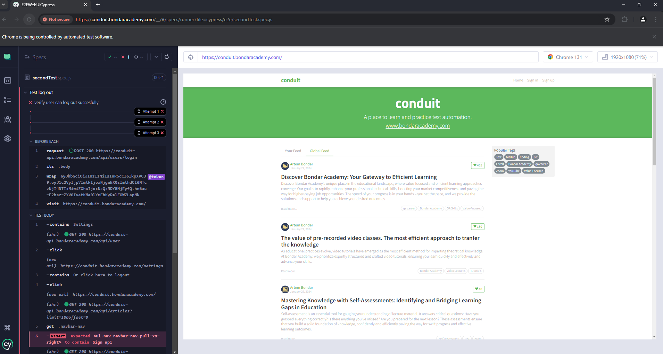

**U can also add it to a test suite level**

[**https://docs.cypress.io/app/tooling/reporters**](https://docs.cypress.io/app/tooling/reporters)

**npm install cypress-multi-reporters mocha-junit-reporter --save-dev**

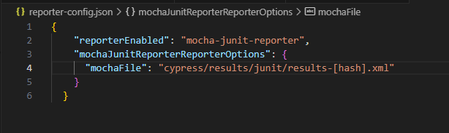

 reporter: 'cypress-multi-reporters',

  reporterOptions: {

    configFile: 'reporter-config.json',

  },

"delete:reports": "rm -r cypress/results/* || true",  
 "prereport": "npm run delete:reports",

**npm install mochawesome mochawesome-merge mochawesome-report-generator junit-merge --save-dev**

{

    "reporterEnabled": "mocha-junit-reporter,mochawesome",

    "mochaJunitReporterReporterOptions": {

      "mochaFile": "cypress/results/junit/results-[hash].xml"

    },

    "reporterOptions": {

        "reportDir": "cypress/results/mochawesome",

        "overwrite": false,

        "html": false,

        "json": true

      }

  }

**npm run cypress:e2e**

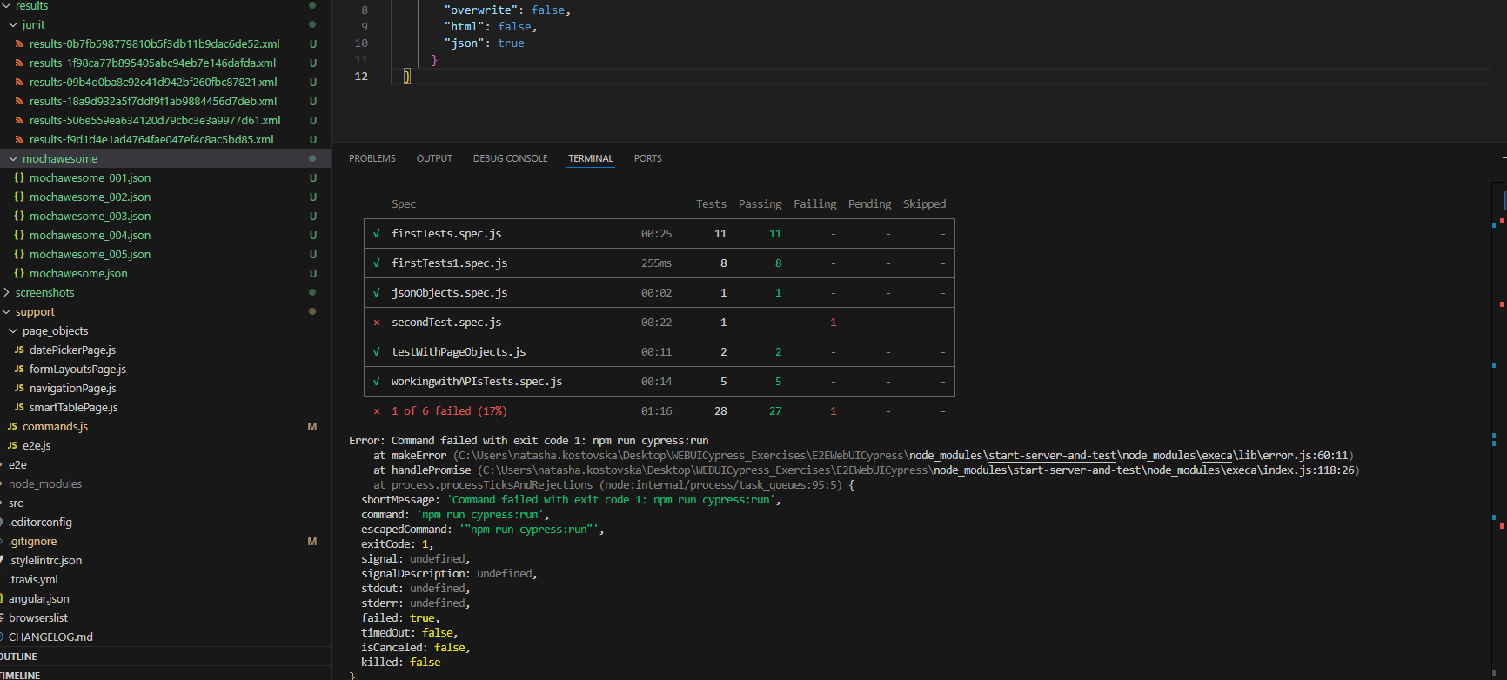

   "mochawesome:merge":"npx mochawesome-merge \"cypress/results/mochawesome/*.json\" > mochawesome.json && npx marge mochawesome.json",

**npm run mochawesome:merge**

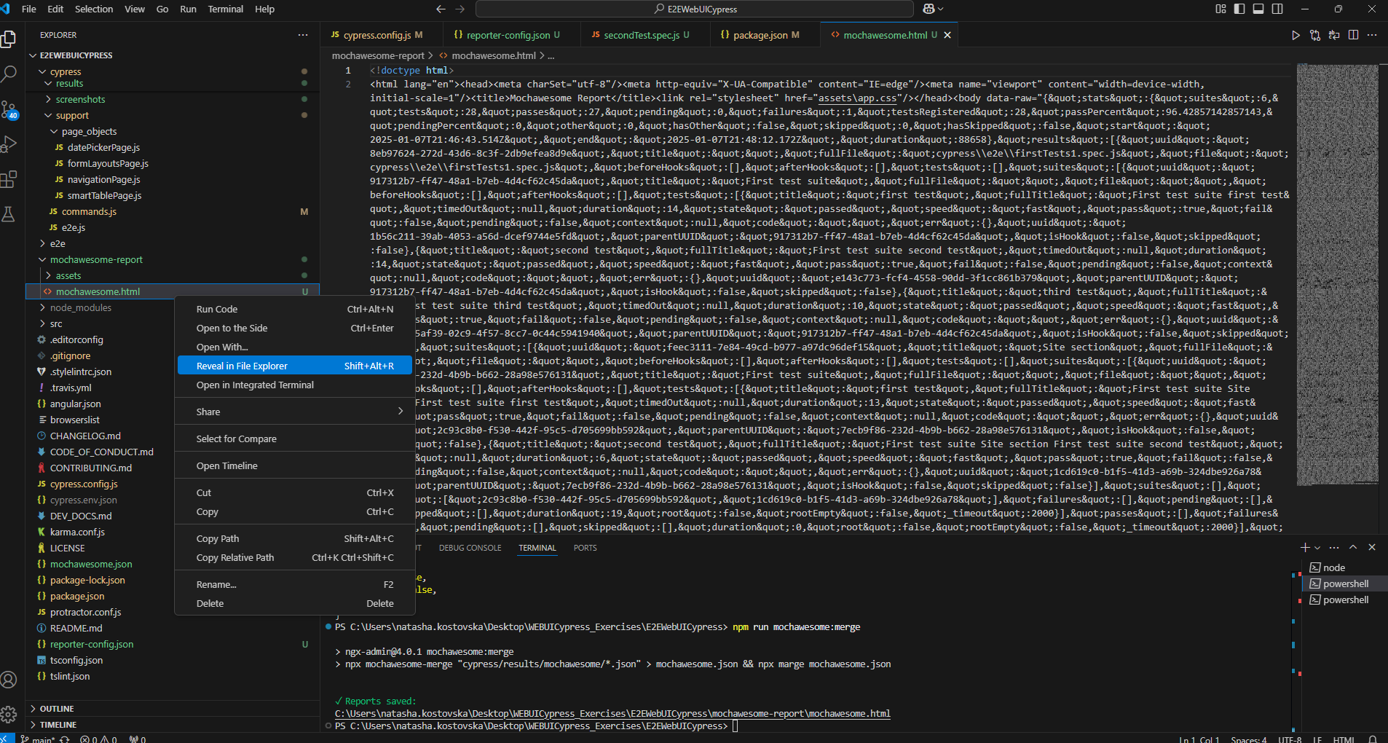

**file:///C:/Users/natasha.kostovska/Desktop/WEBUICypress_Exercises/E2EWebUICypress/mochawesome-report/mochawesome.html**

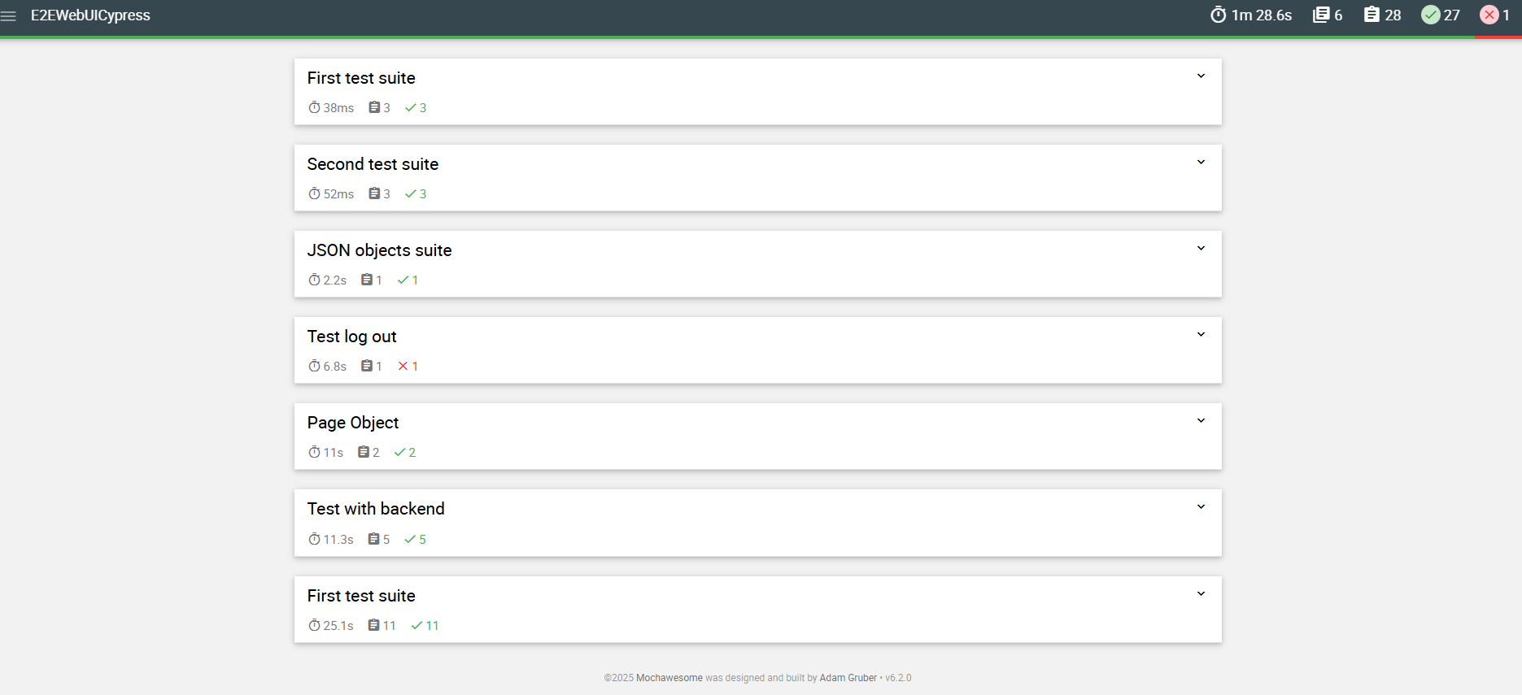

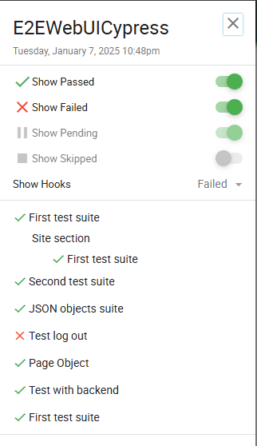

 "junit:merge":"npx junit-merge -d cypress/results/junit -o cypress/results/junit/result.xml",

**npm run junit:merge**

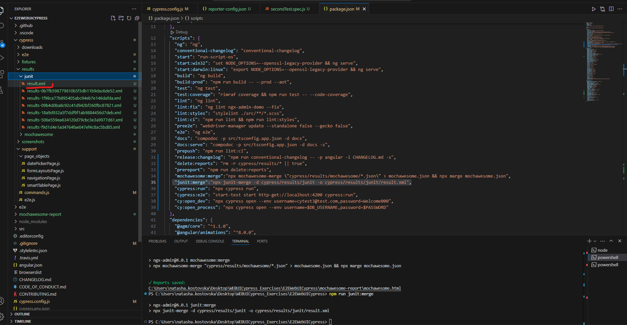

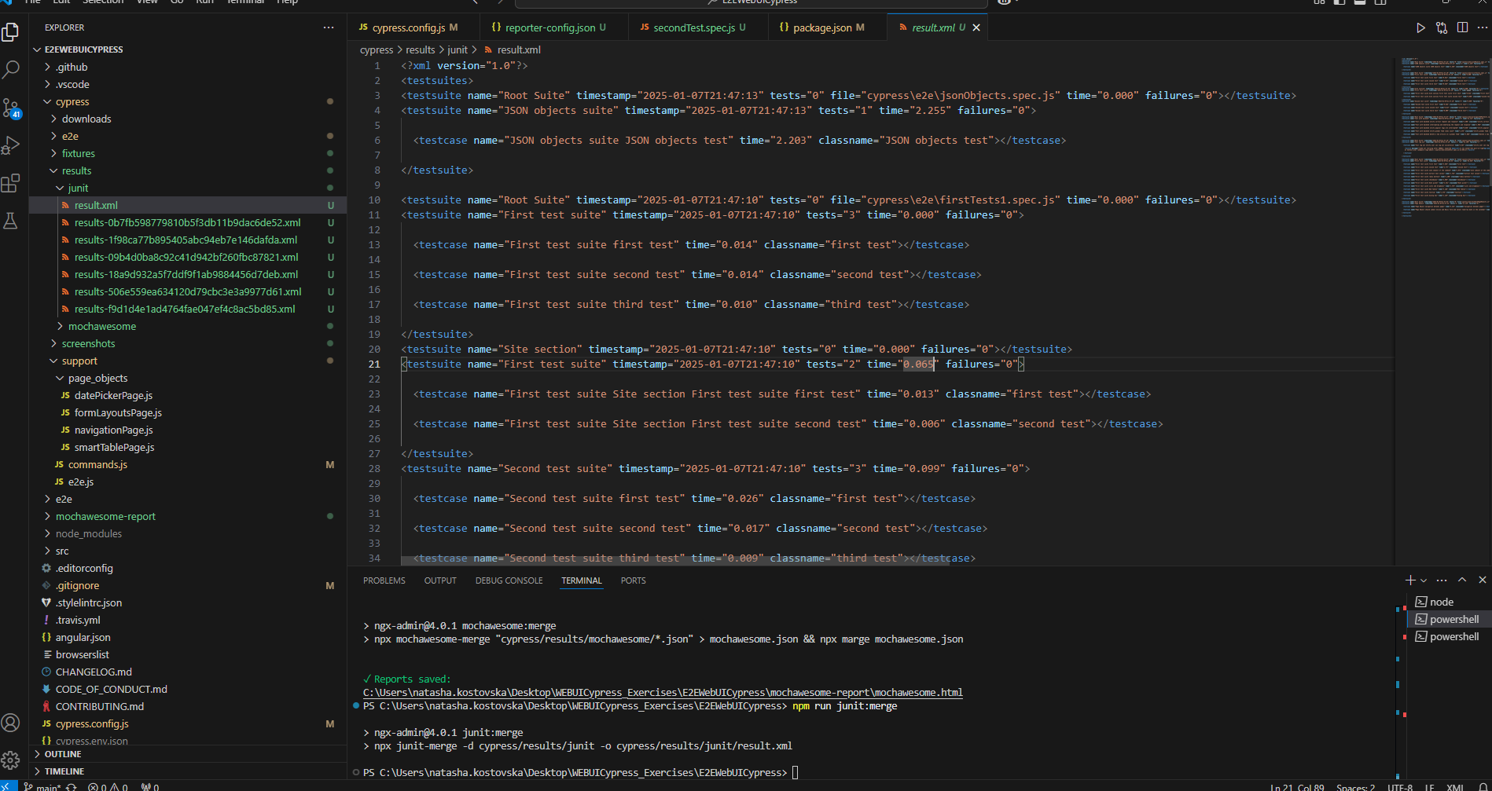

   "cypress:run": "npm run prereport && npx cypress run",

    "cypress:e2e": "start-test start http-get://localhost:4200 cypress:run && npm run junit:merge && npm run mochawesome:merge",

**npm install rimraf --save-dev**

 "delete:reports": "rimraf cypress/results/*",

**npm run cypress:e2e**

**Cypress with Docker container**

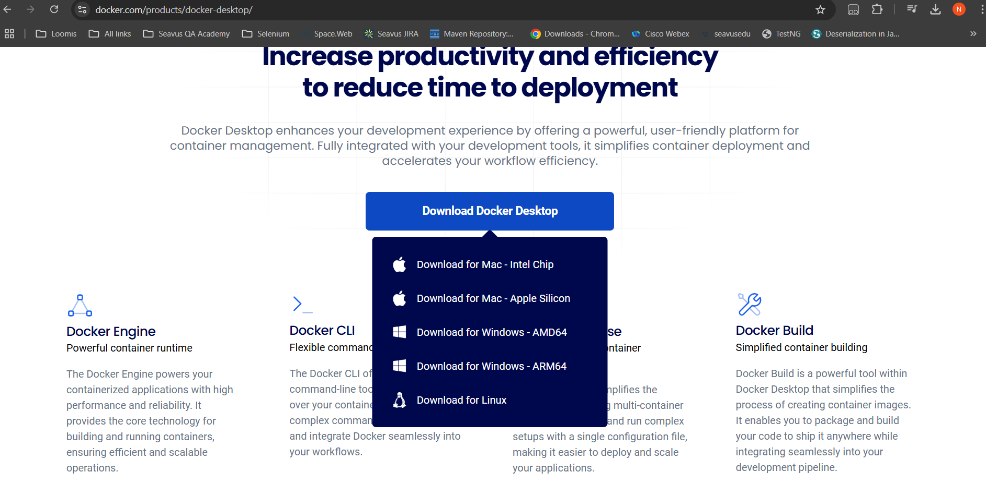

**AMD64**

**1. Architecture Type**

* **AMD64**:
  + Also known as **x86-64**, **x64**, or **Intel 64**.
  + Developed by **AMD**, but also used by **Intel** in their 64-bit processors.
  + It is a **64-bit** extension of the older **x86** (32-bit) architecture.
  + Commonly used in **desktop computers**, **laptops**, **servers**, and **workstations**.
  + AMD64 processors are based on the **CISC (Complex Instruction Set Computing)** architecture.
* **ARM64**:
  + Also known as **AArch64** or **ARMv8-A**.
  + A 64-bit extension of the **ARM** architecture.
  + ARM processors are widely used in **mobile devices**, **tablets**, **embedded systems**, and more recently in **some servers** (e.g., Apple's M1 chip).
  + ARM processors are based on the **RISC (Reduced Instruction Set Computing)** architecture, which is simpler and more power-efficient compared to CISC.

**2. Processor Manufacturers**

* **AMD64** processors are made by **AMD** and **Intel**.
* **ARM64** processors are made by **ARM Holdings** (which designs the architecture) and manufactured by other companies like **Qualcomm**, **Apple**, **Samsung**, and **NVIDIA**.

**3. Power Efficiency**

* **AMD64** (x86-64) processors tend to consume more power, as they are often designed for high performance in desktops and servers.
* **ARM64** processors are generally **more power-efficient**, making them ideal for mobile devices like smartphones, tablets, and low-power embedded systems.

**4. Instruction Set Architecture (ISA)**

* **AMD64** uses the **x86-64** instruction set, which includes a complex set of instructions.
* **ARM64** uses a simpler instruction set, optimized for power efficiency and lower heat output, making it ideal for battery-powered devices.

**5. Software Compatibility**

* **AMD64** processors run software designed for **x86-64**, which is widely used in most desktop and server operating systems, including **Windows**, **Linux**, and **macOS** (on Intel-based Macs).
* **ARM64** processors run software specifically designed for the ARM architecture. However, there is increasing support for ARM-based systems on platforms like **Linux** and **Windows** (Windows 11 on ARM), as well as **Apple's macOS** (on M1/M2 chips).

**6. Use Cases**

* **AMD64**:
  + Predominantly used in **desktops**, **laptops**, and **servers**.
  + Excellent for workloads requiring high processing power, such as gaming, data centers, and video editing.
* **ARM64**:
  + Common in **mobile devices** (smartphones, tablets), **embedded systems**, and **low-power devices**.
  + Recently, ARM processors are gaining traction in **servers** and **laptops** (e.g., **Apple M1/M2**, **Microsoft Surface Pro X** with ARM).

**7. Performance**

* **AMD64** processors are typically more powerful for computationally intensive tasks.
* **ARM64** processors, while generally lower in performance compared to AMD64 for tasks like gaming or heavy multitasking, are much better at handling mobile or embedded workloads that require high power efficiency.

**8. Example Processors**

* **AMD64** (x86-64) processors: **Intel Core i7**, **AMD Ryzen**, **Intel Xeon**.
* **ARM64** processors: **Apple M1/M2**, **Qualcomm Snapdragon 8xx series**, **Samsung Exynos**, **NVIDIA Jetson**.

**9. Software/Operating System Support**

* **AMD64**:
  + Supported by almost all desktop and server operating systems (Windows, Linux, macOS).
* **ARM64**:
  + Supported by newer versions of **Android**, **iOS**, **macOS** (for Apple Silicon), and **Windows 11** (for ARM-based PCs).

**Need to register so I can connect to the docker registry and download the images**

[**https://app.docker.com/signup?state=hKFo2SBGbXR4Vjc1c3VhM05tRjdYZ3BYTnNjSkkxWHBJMWd4VqFur3VuaXZlcnNhbC1sb2dpbqN0aWTZIE1vdWQ0RXdzcjk4cUl2aURtTzVpQlZfb3ZaU2V0V0dOo2NpZNkgRmkyQ0VleDZtMzhkS1lxdnZaWVljSms5SUN0cGc3ZzQ**](https://app.docker.com/signup?state=hKFo2SBGbXR4Vjc1c3VhM05tRjdYZ3BYTnNjSkkxWHBJMWd4VqFur3VuaXZlcnNhbC1sb2dpbqN0aWTZIE1vdWQ0RXdzcjk4cUl2aURtTzVpQlZfb3ZaU2V0V0dOo2NpZNkgRmkyQ0VleDZtMzhkS1lxdnZaWVljSms5SUN0cGc3ZzQ)

[**https://docs.cypress.io/app/continuous-integration/overview**](https://docs.cypress.io/app/continuous-integration/overview)

### Cypress Docker variants[​](https://docs.cypress.io/app/continuous-integration/overview#Cypress-Docker-variants)

* [cypress/base](https://github.com/cypress-io/cypress-docker-images/tree/master/base) is the entry-level Cypress Docker image, allowing you to test in the Electron browser, built in to Cypress. It contains a complete Linux (Debian) operating system, together with the [prerequisite operating system packages](https://docs.cypress.io/app/get-started/install-cypress#UbuntuDebian) for Cypress, Node.js, npm and Yarn v1 Classic. An image <tag> gives you the choice of Node.js version.
* [cypress/browsers](https://github.com/cypress-io/cypress-docker-images/tree/master/browsers) builds on the [cypress/base](https://github.com/cypress-io/cypress-docker-images/tree/master/base) image. For Linux/amd64 images it adds **Chrome**, **Firefox** and **Edge** browsers. A corresponding image <tag> allows selection of the combined Node.js and browser versions. (Currently Linux/arm64 images do **not** contain browsers.)
* [cypress/included](https://github.com/cypress-io/cypress-docker-images/tree/master/included) builds on the [cypress/browsers](https://github.com/cypress-io/cypress-docker-images/tree/master/browsers) image. It adds a fixed version of **Cypress**, globally installed by npm. A short-form image <tag> selects the version of Cypress. A corresponding long-form <tag> selects the version of Cypress and documents the combined Node.js and browser versions.
* [cypress/factory](https://github.com/cypress-io/cypress-docker-images/tree/master/factory) provides the base operating system image and allows individual selection of other components by version. It is used to generate customized Docker images.

**Always using the first one base one**

**Needs to be the same version as node version on the project** [**https://hub.docker.com/r/cypress/base/tags?name=20.11.0**](https://hub.docker.com/r/cypress/base/tags?name=20.11.0)

[**https://github.com/cypress-io/cypress-docker-images/tree/master/base**](https://github.com/cypress-io/cypress-docker-images/tree/master/base)

**docker image has own os system and all dependencies needed to run the tests**

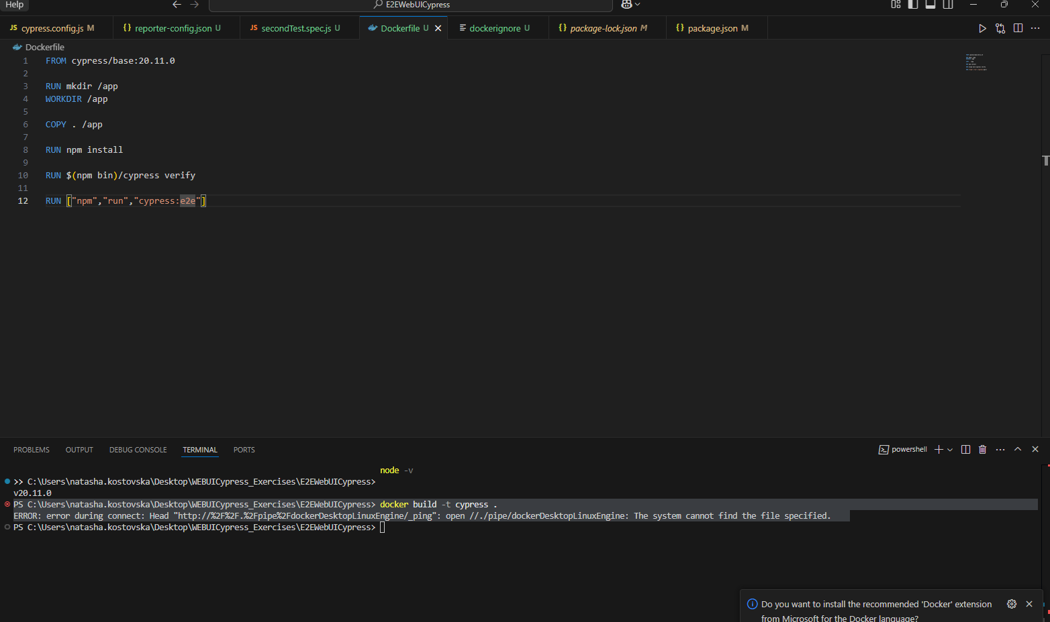

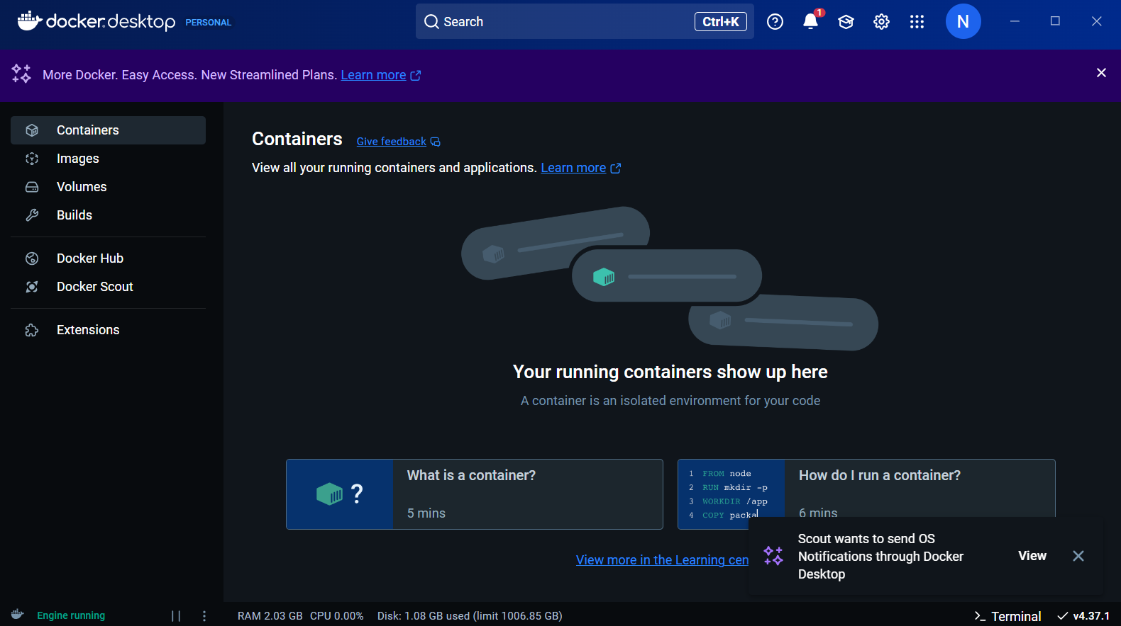

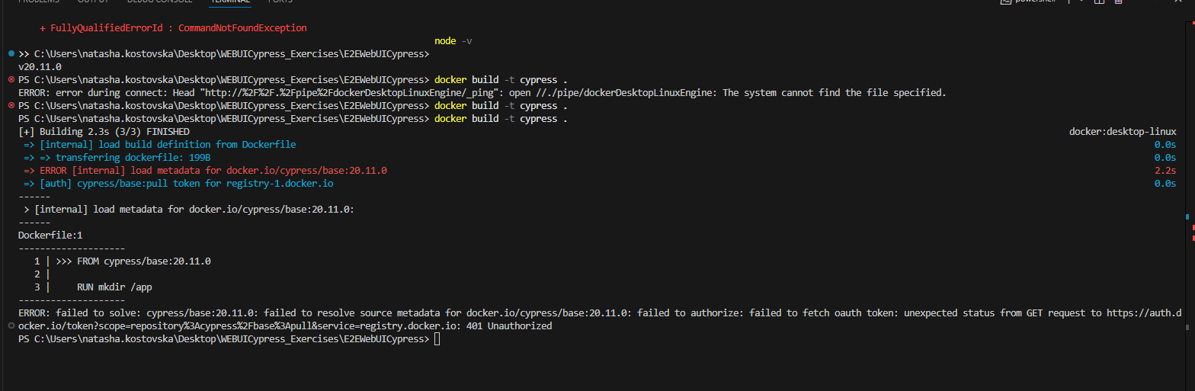

**Dokerfile always needs to be with capital letter, created another docker ignore file so node modules would not be added**

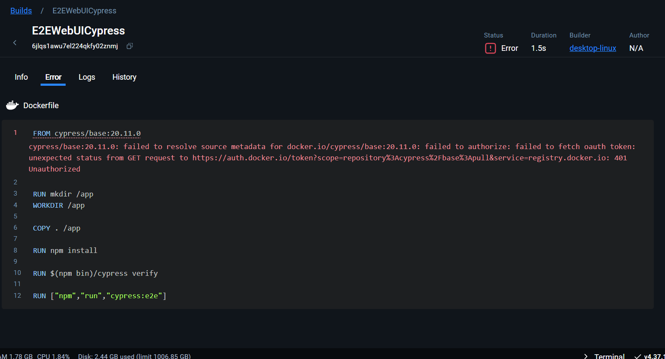

**Needed to verify the account on my email and then try terminal command**

**docker build -t cypress .**

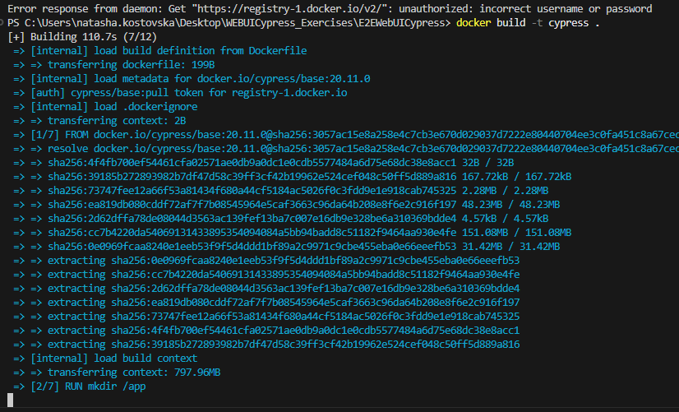

**Another error**

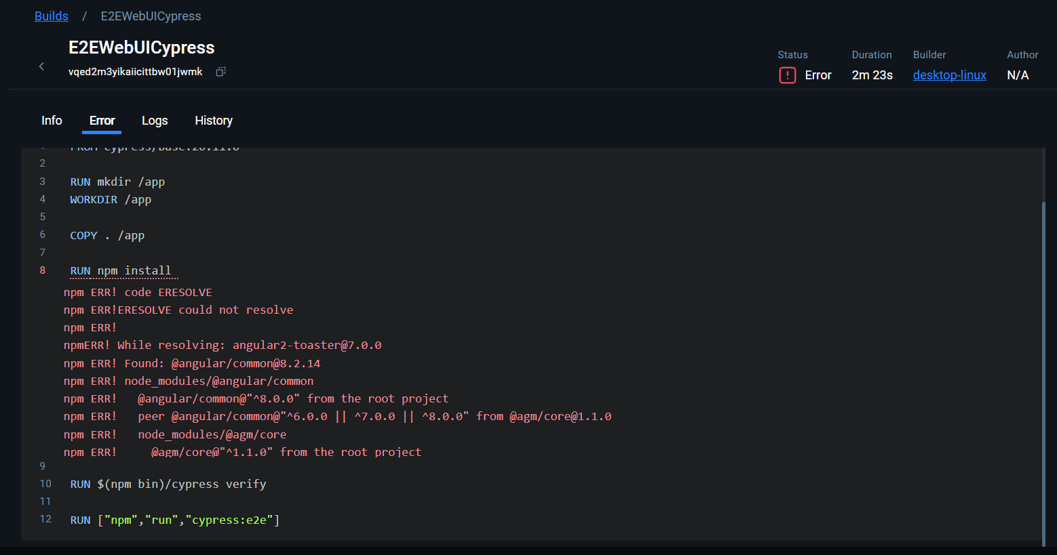

**Added** RUN npm install --legacy-peer-deps

**But another error**

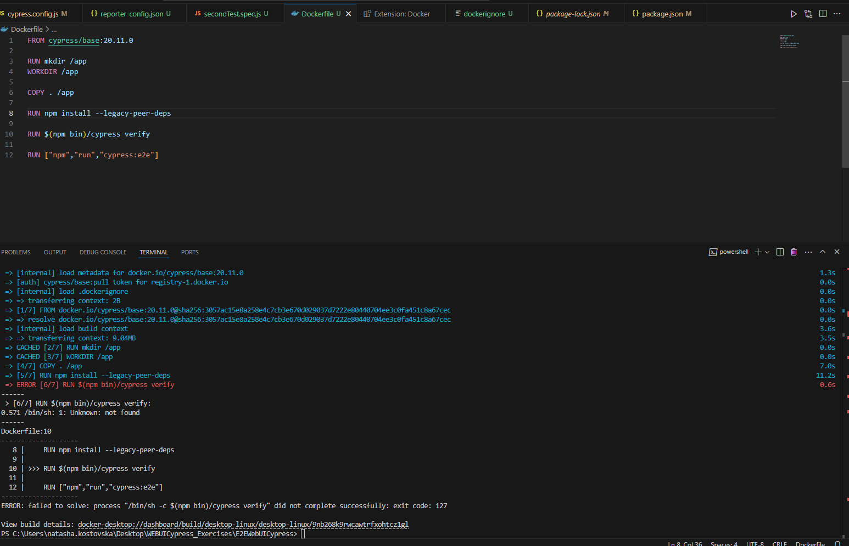

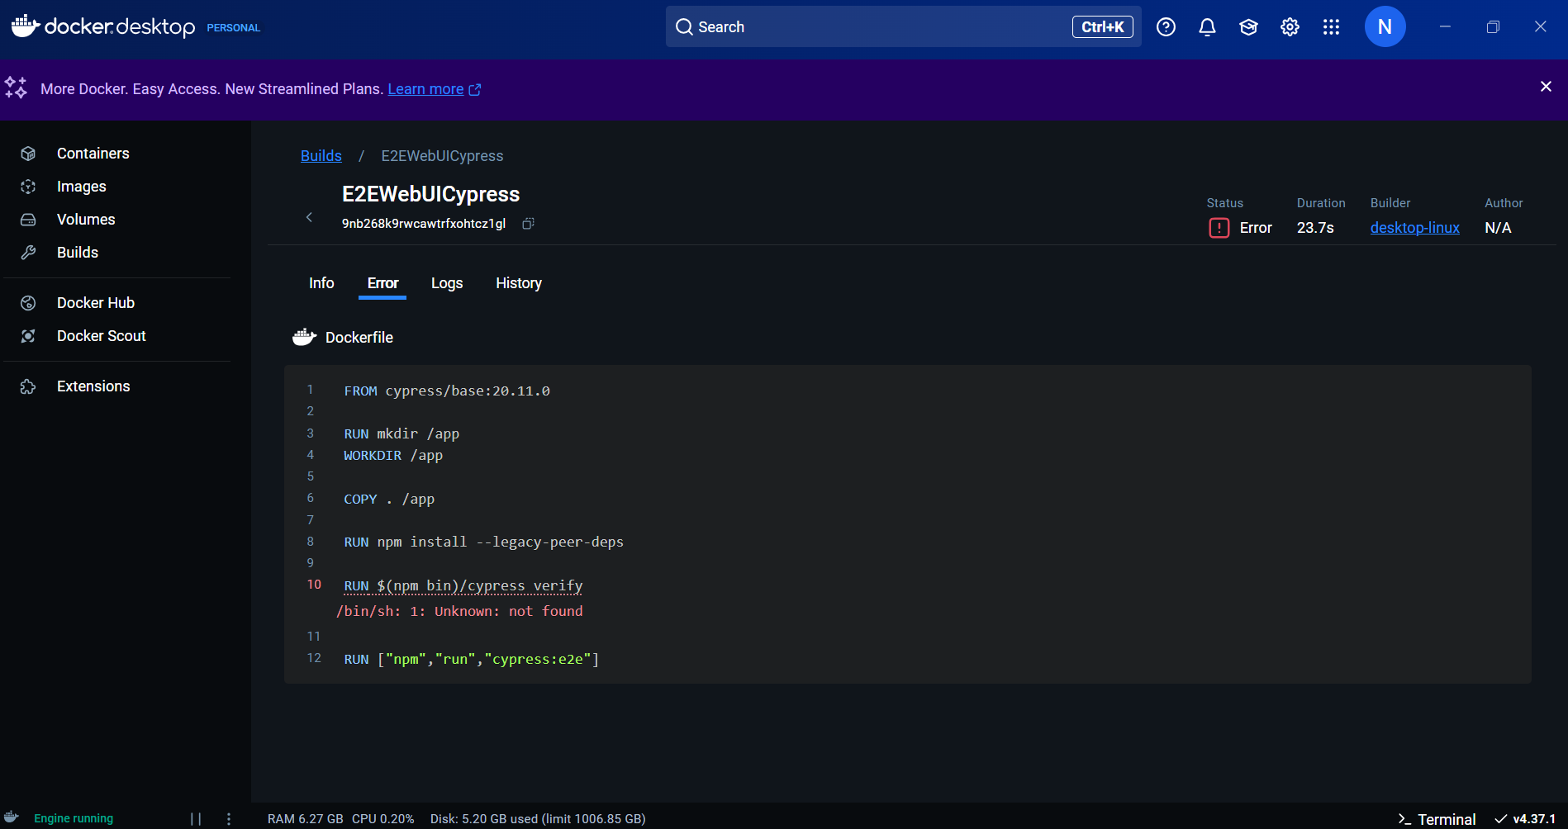

**Changed**

RUN npx cypress verify

**!!!!!!!FINAL docker file for windows without errors**

FROM cypress/base:20.11.0

# Set up the working directory for the app

RUN mkdir /app

WORKDIR /app

# Copy the application files into the Docker image

COPY . /app

# Install npm dependencies, resolving peer conflicts

RUN npm install --legacy-peer-deps

# Install Cypress binary

RUN npx cypress install && npx cypress verify

# Cache Cypress binary to avoid re-downloading in future builds

RUN mkdir -p ~/.cache/Cypress

# Run Cypress tests after the server is up and running

CMD ["npm", "run", "cypress:e2e"]

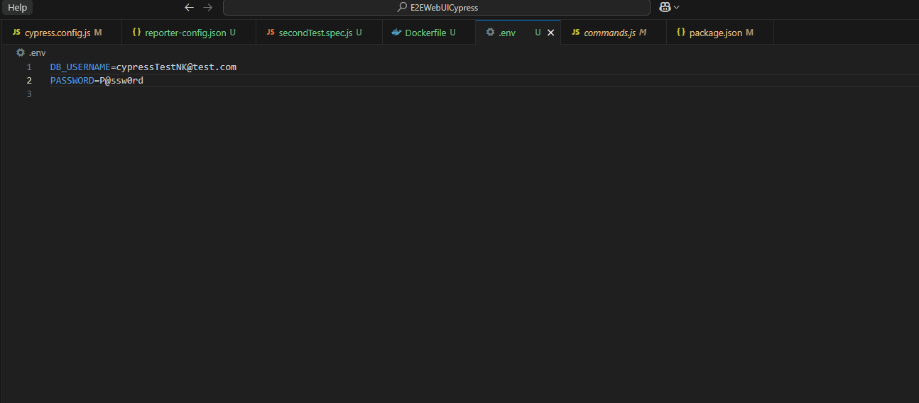

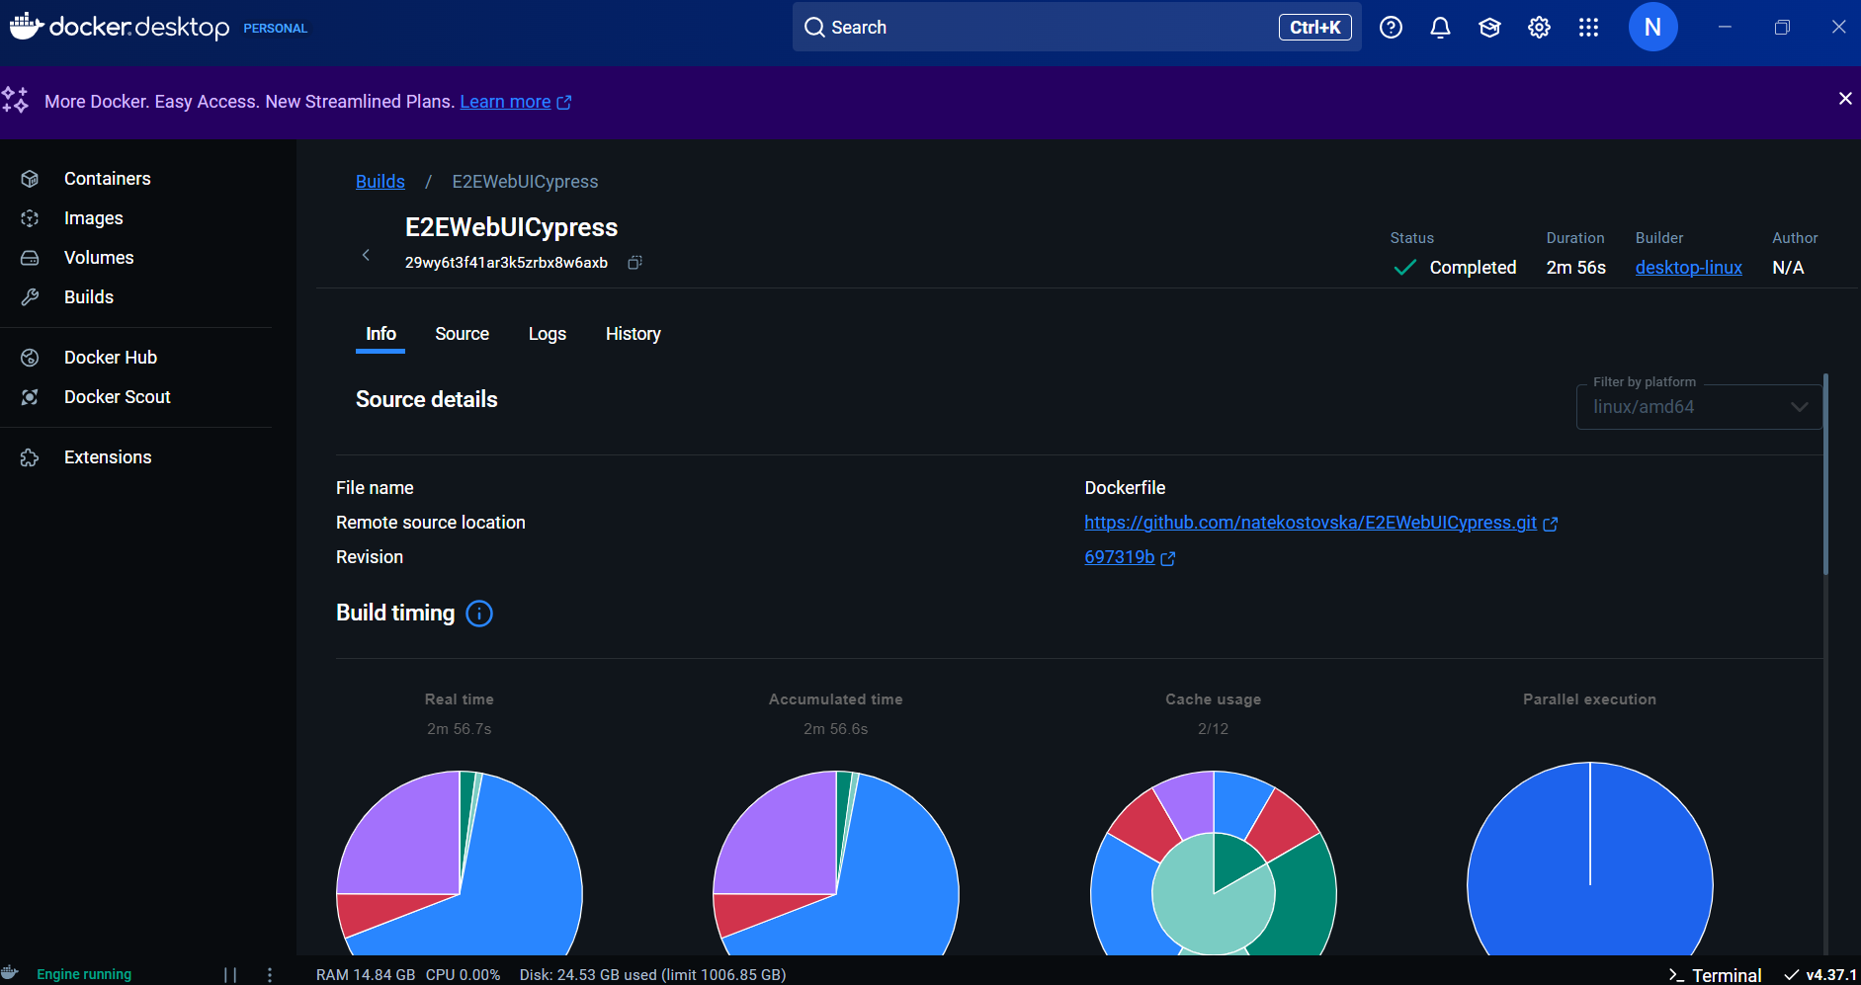

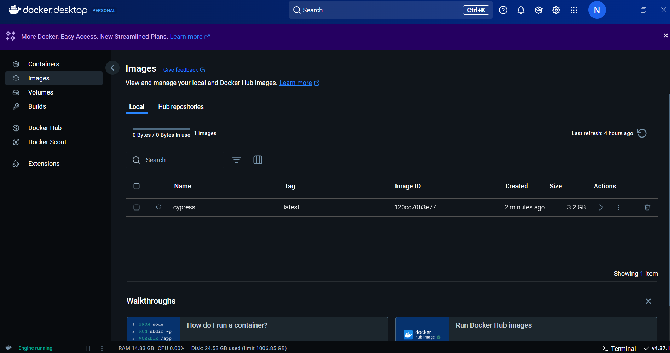

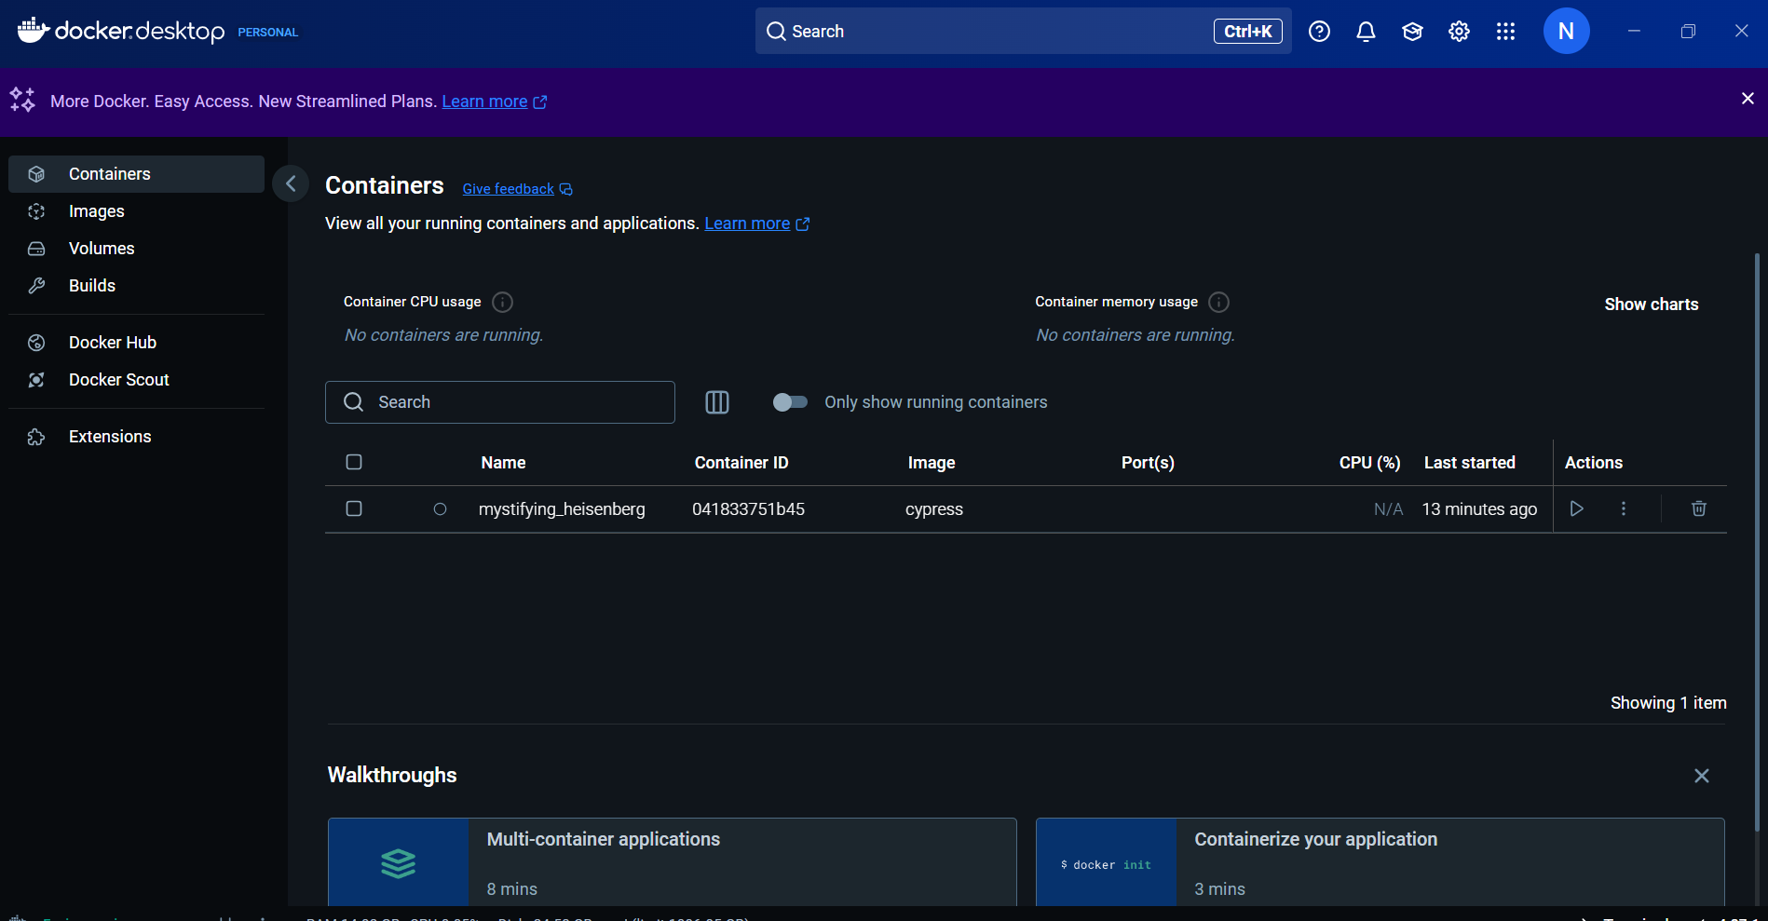

**CREATE DOCKER COMPOSE YML file**

**----------------------------------------------**

**OKTA**

**Identity management platform/ security for the application is much complicated with cypress it blocks the redirection**

**CROSS BROWSER TESTING SCRIPT**

  "cy:run_spec":"npx cypress run --spec 'cypress/e2e/testWithPageObjects.spec.js' --browser chrome"

**npm run** cy:run_spec

  "cy:run_spec":"npx cypress run --spec 'cypress/e2e/testWithPageObjects.spec.js' --browser edge"

**npm run** cy:run_spec

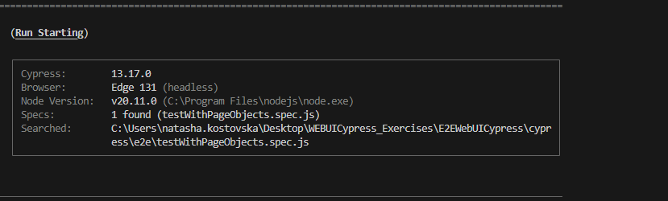

**If we wat headed mode, that above was headless**

"cy:run_spec":"npx cypress run --spec 'cypress/e2e/testWithPageObjects.spec.js' --browser firefox --headed"

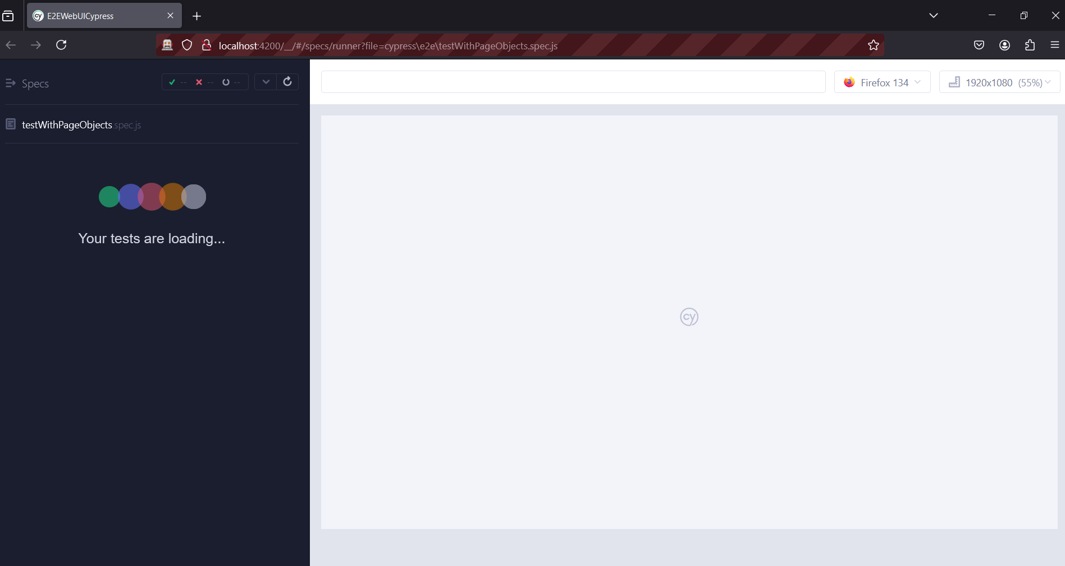

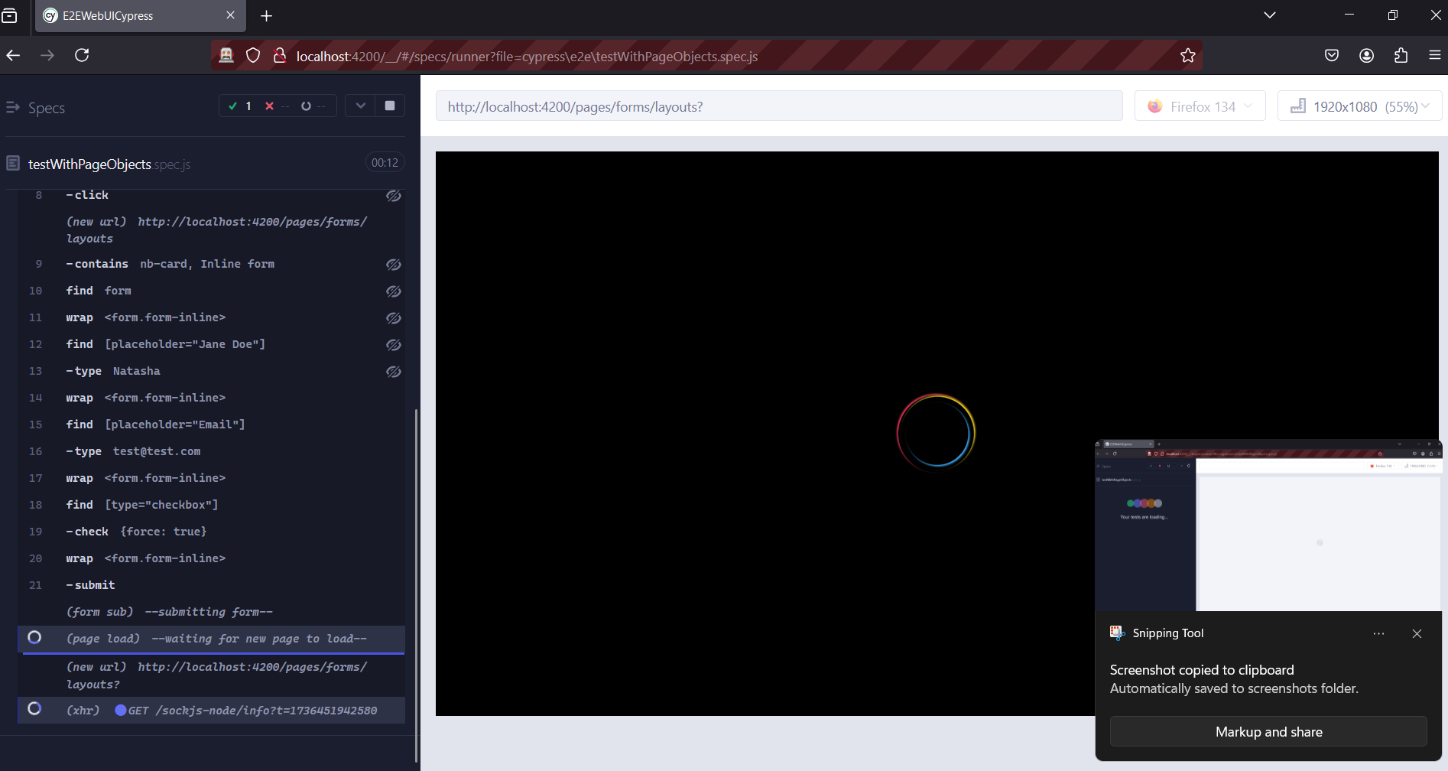

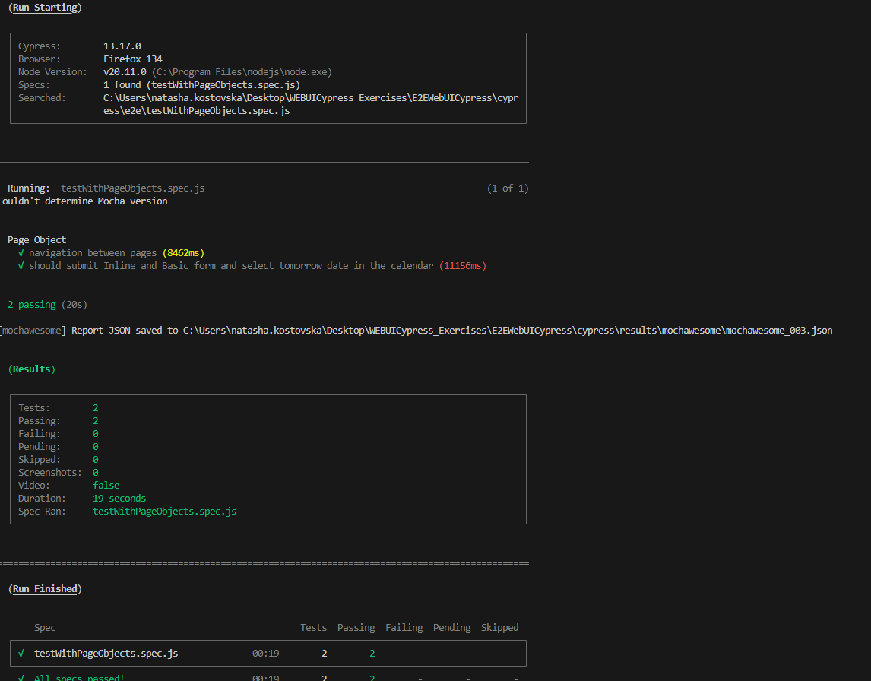

**If we want to execute the test only in chrome**

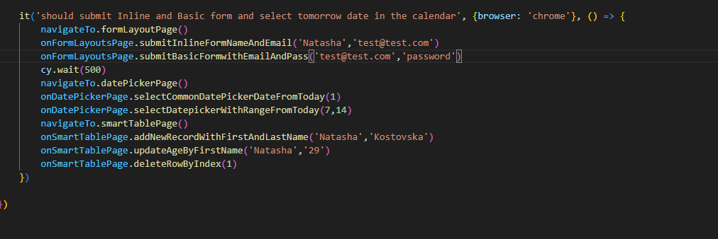

**And again execute the tests with**     "cy:run_spec":"npx cypress run --spec 'cypress/e2e/testWithPageObjects.spec.js' --browser firefox --headed"

**npm run** cy:run_spec

**only the first test will be executed, the second for chrome wont be**

**We don’t want to run the test in firefox**

    it('should submit Inline and Basic form and select tomorrow date in the calendar', {browser: '!firefox'}, () => {

        navigateTo.formLayoutPage()

        onFormLayoutsPage.submitInlineFormNameAndEmail('Natasha','test@test.com')

        onFormLayoutsPage.submitBasicFormwithEmailAndPass('test@test.com','password')

        cy.wait(500)

        navigateTo.datePickerPage()

        onDatePickerPage.selectCommonDatePickerDateFromToday(1)

        onDatePickerPage.selectDatepickerWithRangeFromToday(7,14)

        navigateTo.smartTablePage()

        onSmartTablePage.addNewRecordWithFirstAndLastName('Natasha','Kostovska')

        onSmartTablePage.updateAgeByFirstName('Natasha','29')

        onSmartTablePage.deleteRowByIndex(1)

    })

**Wont be executed in firefox and edge**

 it('should submit Inline and Basic form and select tomorrow date in the calendar', {browser: ['!firefox','!edge']}, () => {

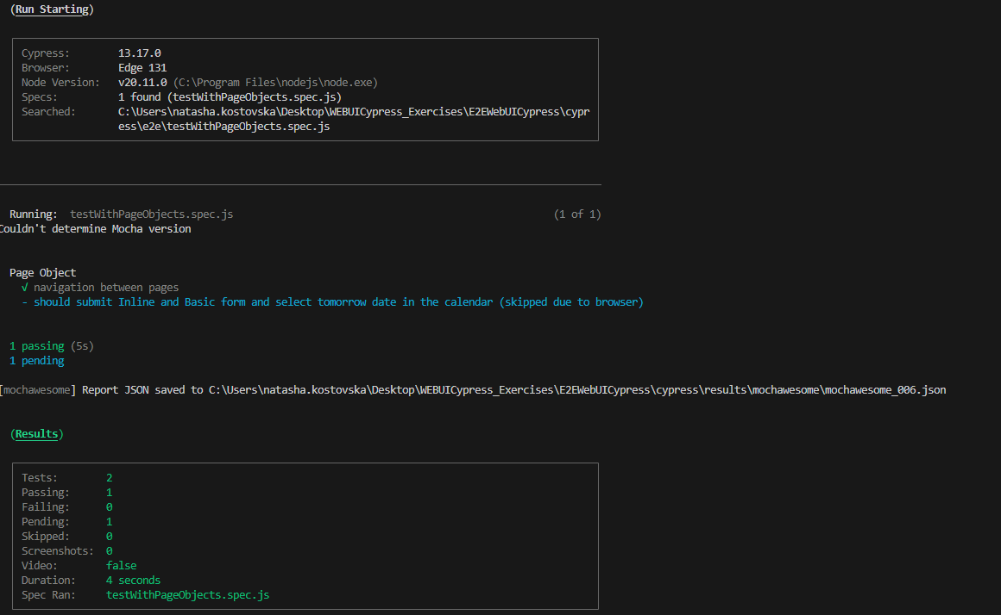

**U can also specify this in the describe block**

**Experimental web kit**

experimentalWebKitSupport: true,

[**https://docs.cypress.io/app/references/launching-browsers#WebKit-Experimental**](https://docs.cypress.io/app/references/launching-browsers#WebKit-Experimental)

**npm install playwright-webkit --save-dev**

 "cy:run_spec": "npx cypress run --spec 'cypress/e2e/testWithPageObjects.spec.js' --browser webkit --headed"

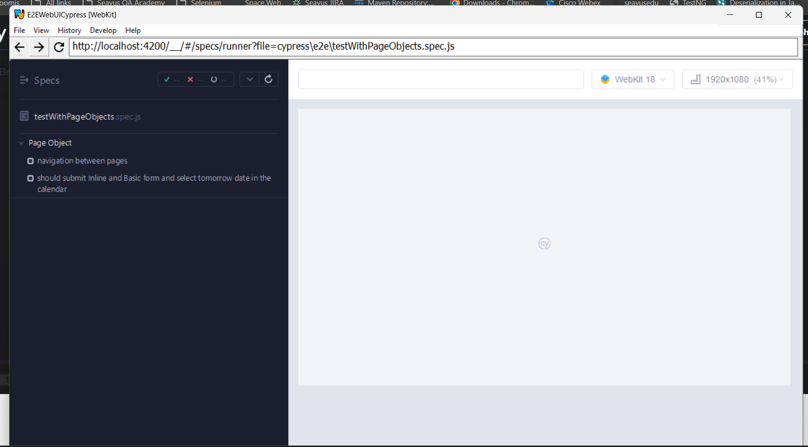

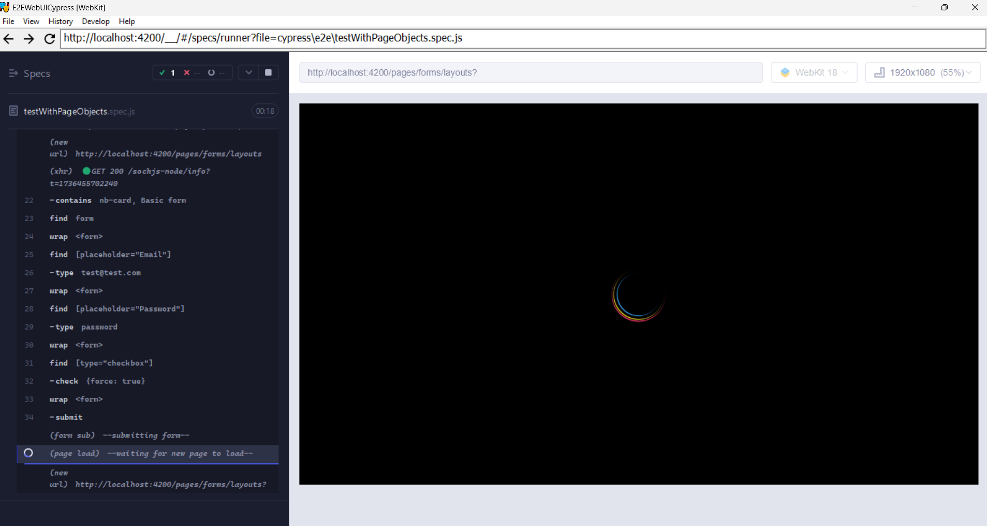

**Shadow dom**

[**https://docs.cypress.io/api/commands/shadow**](https://docs.cypress.io/api/commands/shadow)

describe('shadow dom',()=>{

    it('access shadow dom', ()=>{

        cy.visit('https://radogado.github.io/shadow-dom-demo/')

        cy.get('#app').shadow().find('#container')

    })

})

**Cypress dashboard**

[**https://www.cypress.io/cloud**](https://www.cypress.io/cloud)

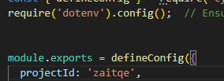

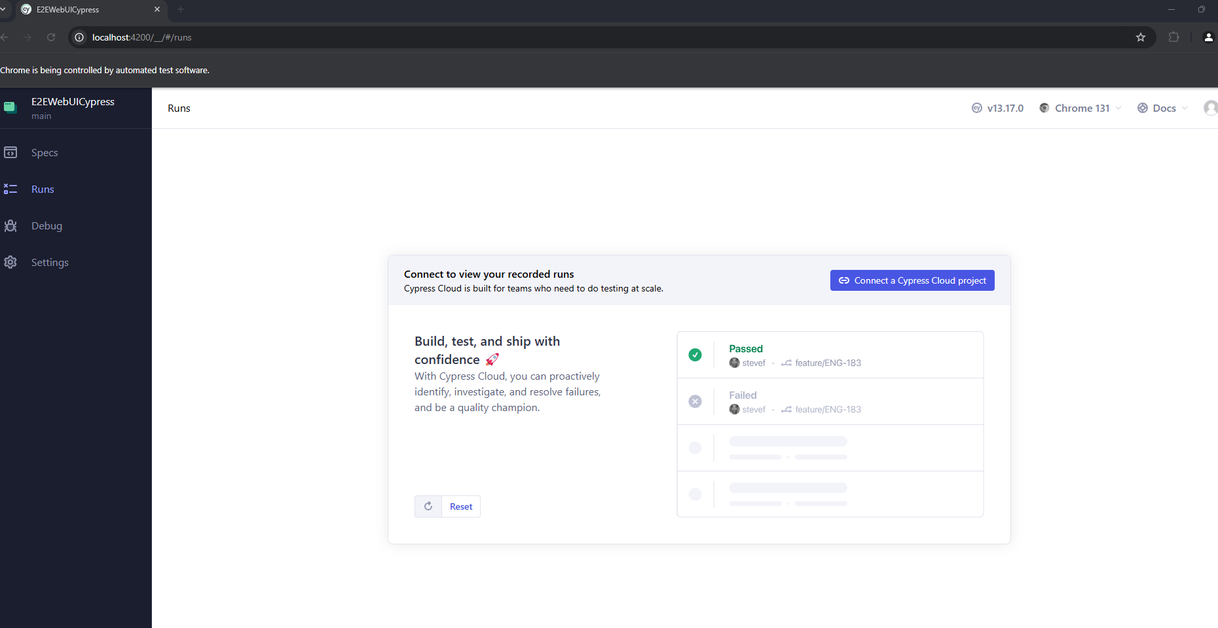

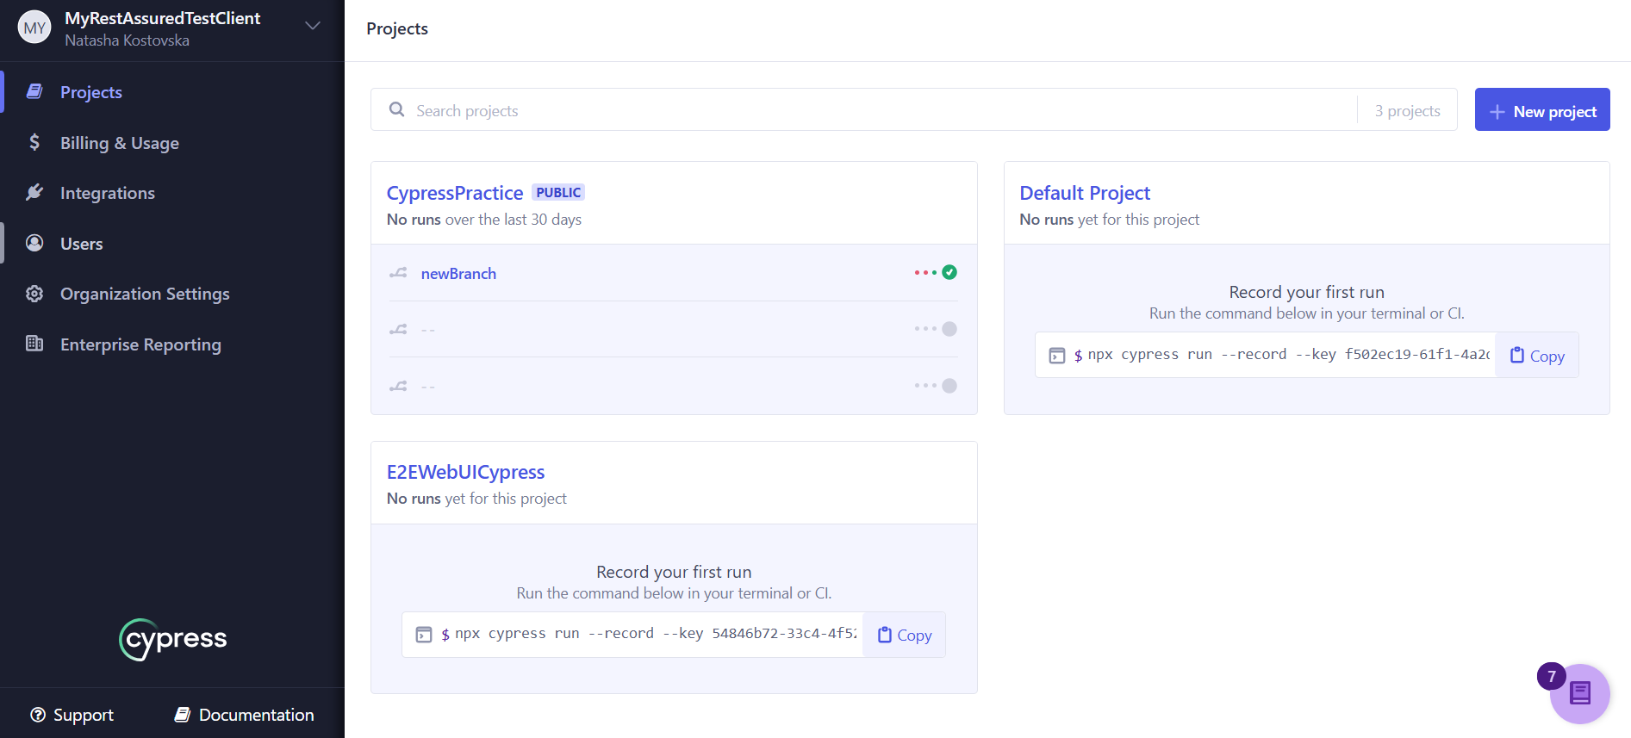

npx cypress run --record --key 54846b72-33c4-4f52-a673-89aaa8a14ac5

**add in package json** "cy:run_spec": "npx cypress run --spec 'cypress/e2e/testWithPageObjects.spec.js' --headless --record --key 54846b72-33c4-4f52-a673-89aaa8a14ac5"

**npm run cy:run_spec**

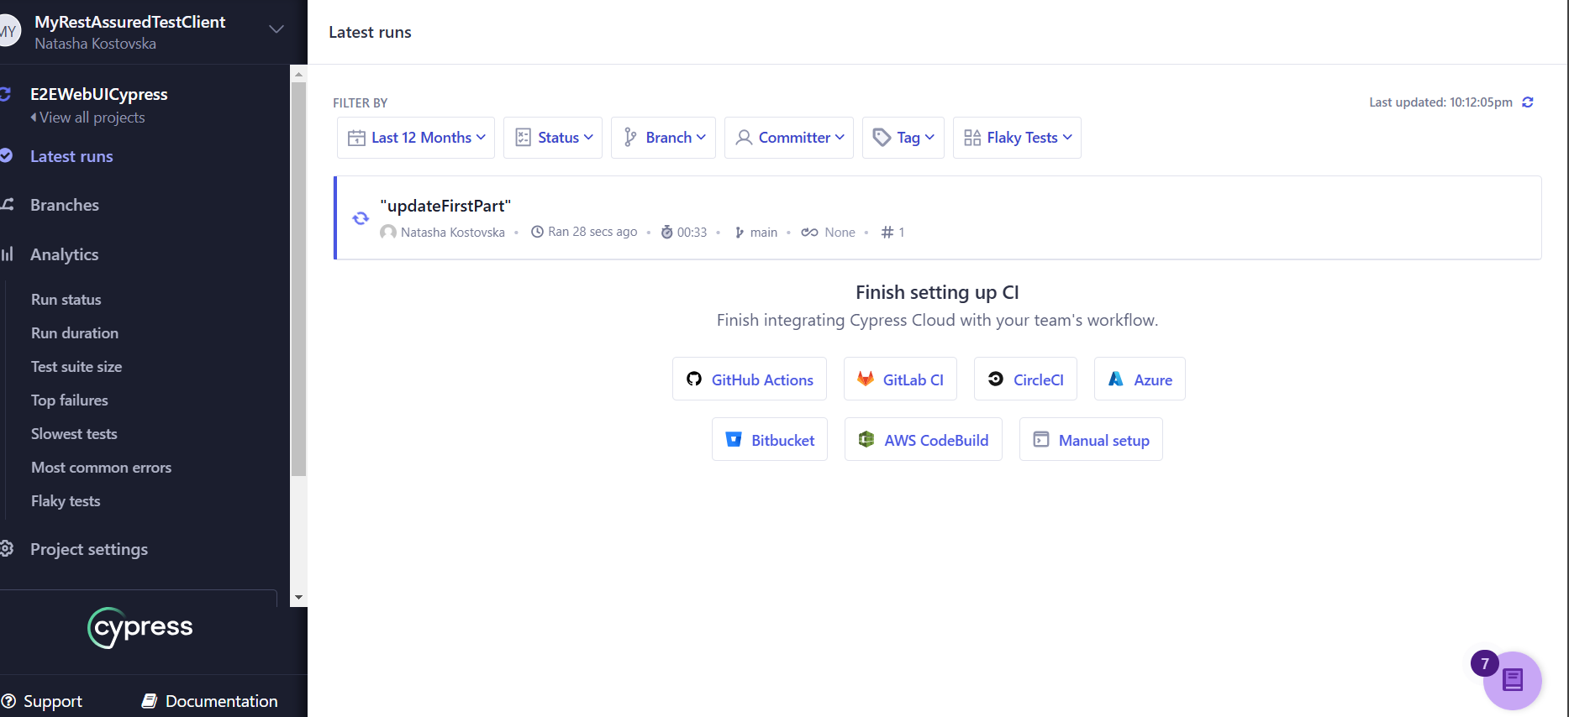

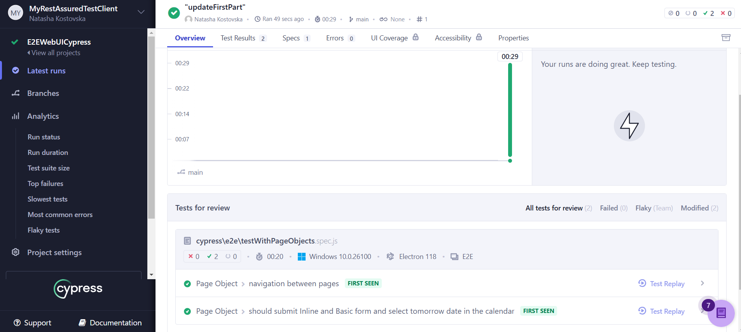

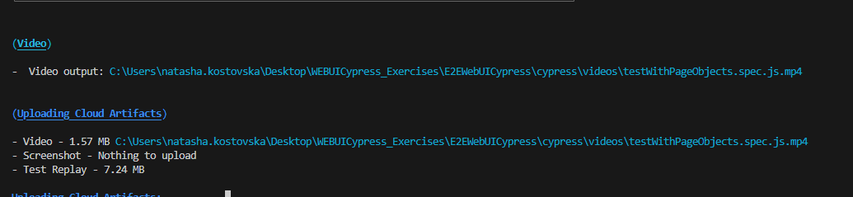

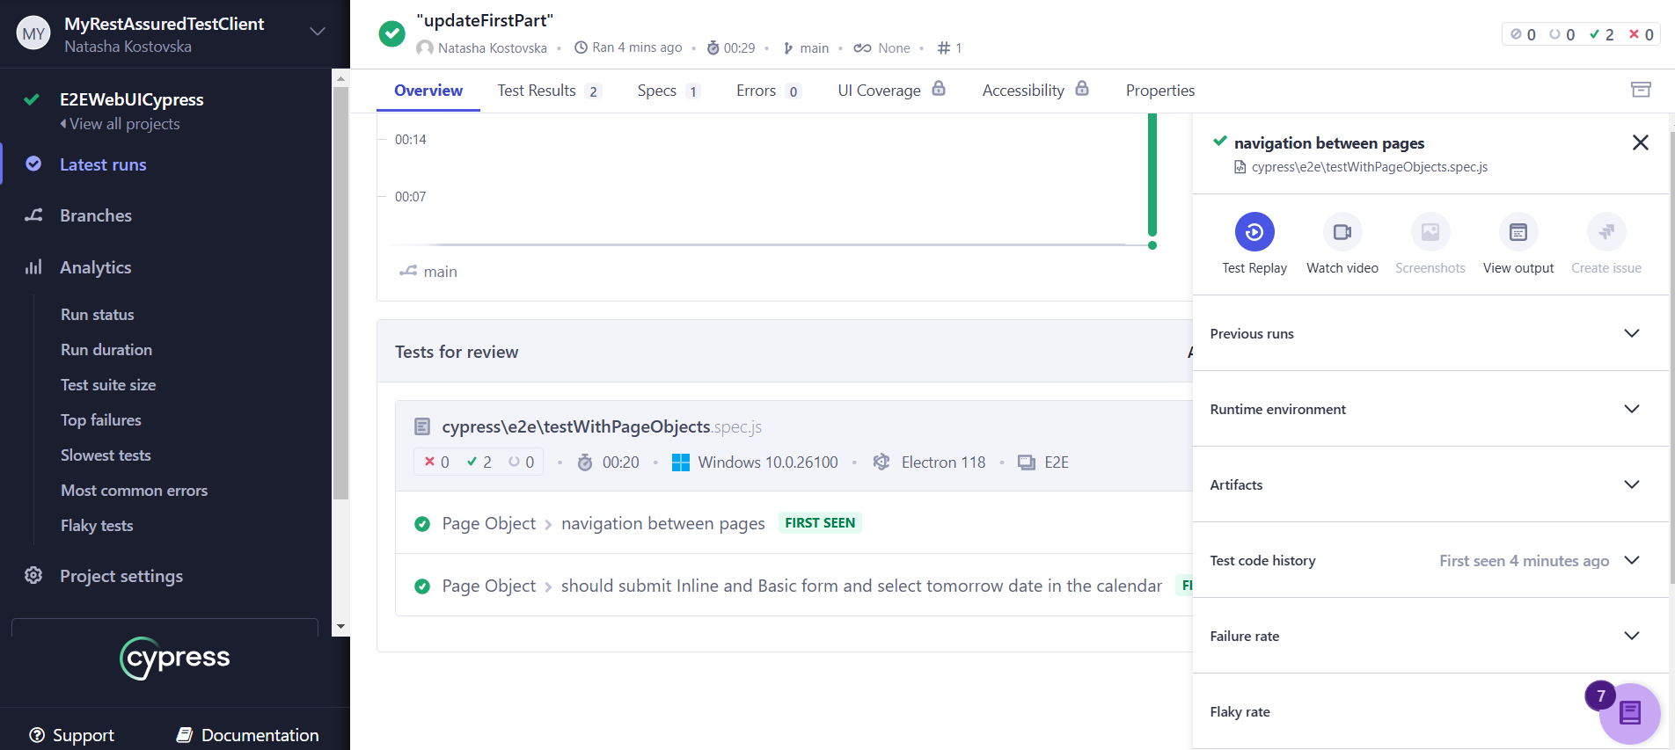

**Grouping the tests by browser**

  "cy:run_browser": "npm run cy:run_spec -- --browser firefox --group Firefox --ci-build-id 1 & npm run cy:run_spec -- --browser chrome --group Chrome --ci-build-id 1"

**npm run cy:run_browser**

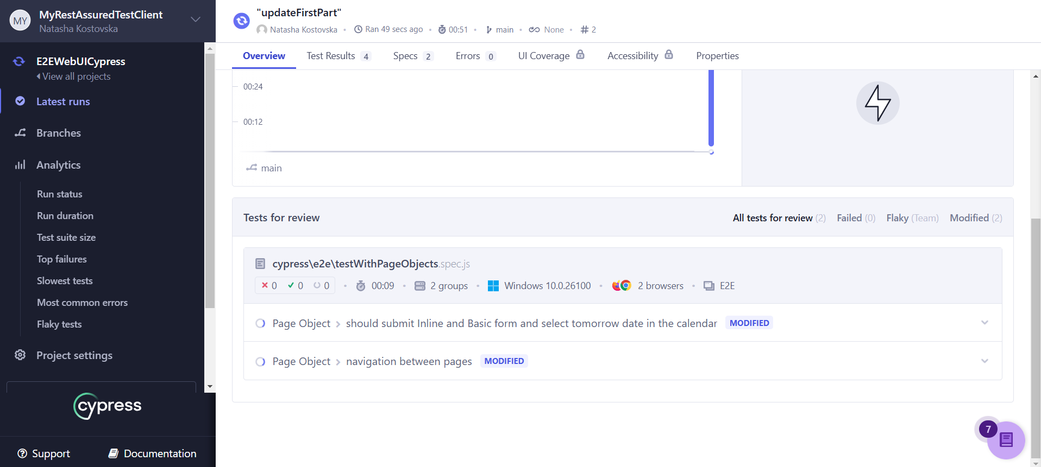

**We are running two tests in parallel for chrome and firefox**

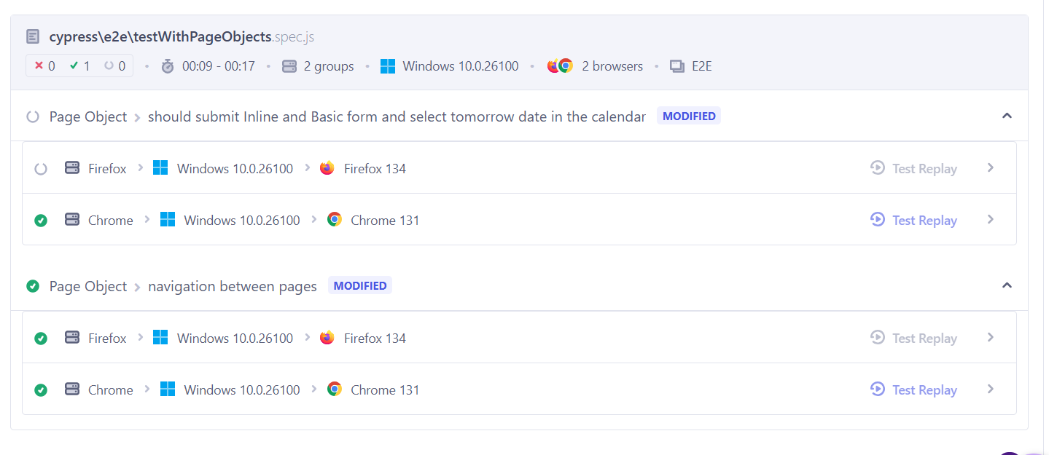

**HOW TO RUN TESTS IN PARALLEL USING CI Server**

"cy:run":"npx cypress run --headless --record --key 54846b72-33c4-4f52-a673-89aaa8a14ac5 --parallel"

**-java -jar "C:\Users\natasha.kostovska\Downloads\jenkins.war"**

**Cypress by default does not support visual testing**

**So we can use apitool**

[**https://applitools.com/**](https://applitools.com/)

[**https://eyes.applitools.com/app/test-results/00000251782777976964/?accountId=Yibmtmf0P0_uyZmlX7i64w~~**](https://eyes.applitools.com/app/test-results/00000251782777976964/?accountId=Yibmtmf0P0_uyZmlX7i64w~~)

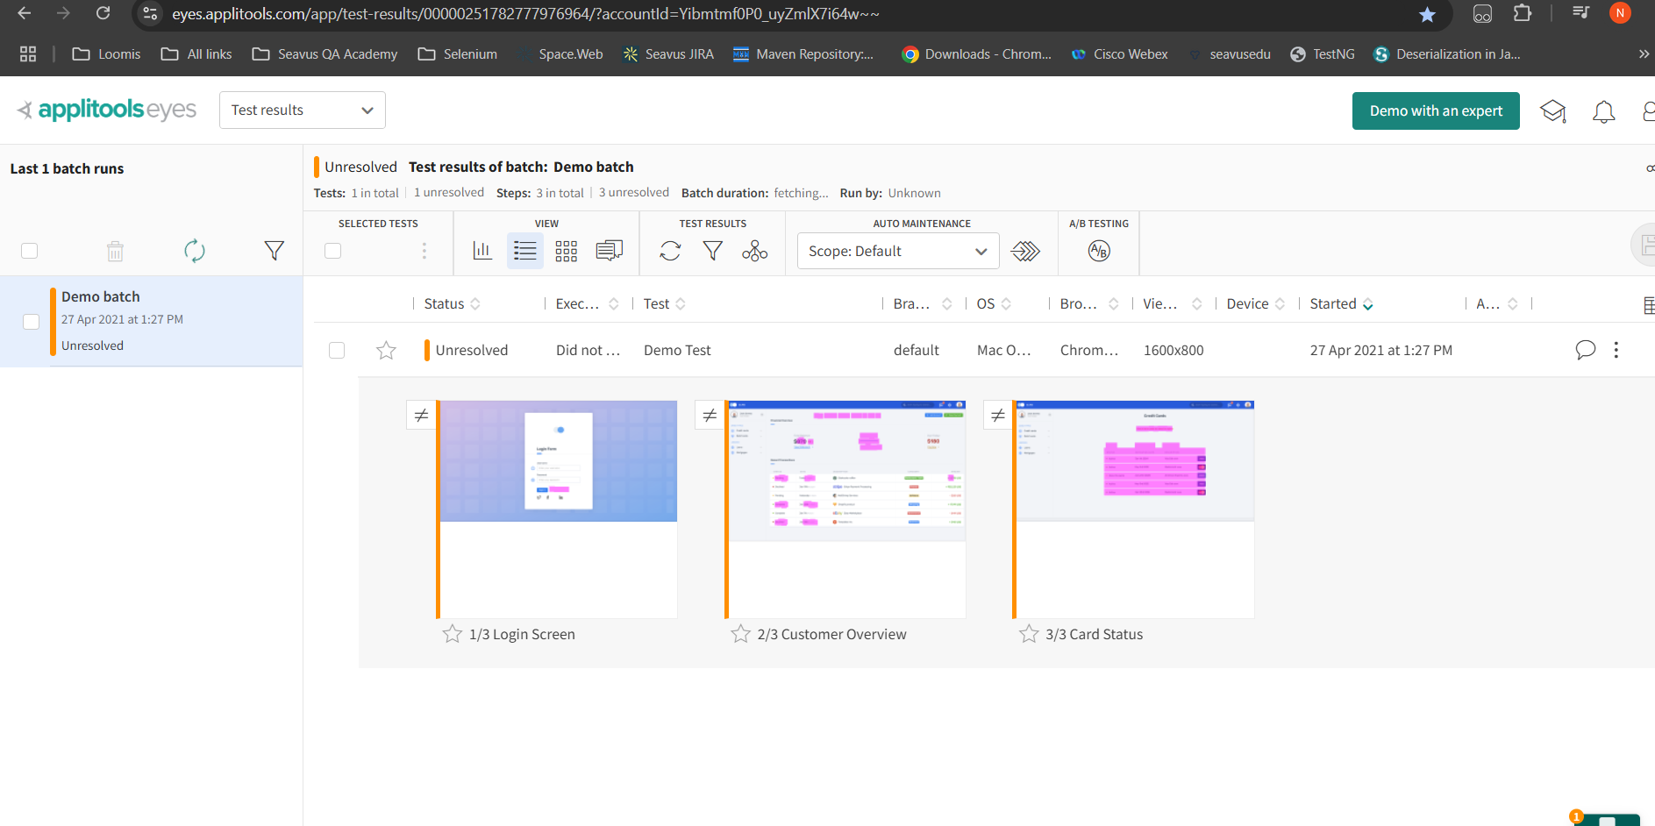

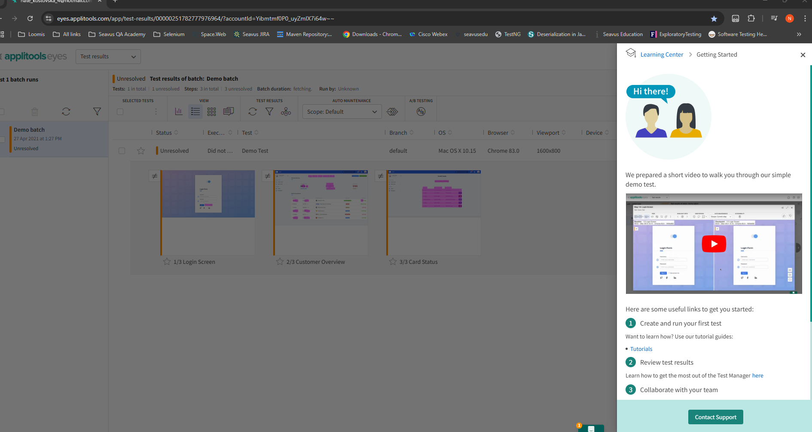

[**https://applitools.com/tutorials/**](https://applitools.com/tutorials/)

[**https://applitools.com/tutorials/sdks/cypress**](https://applitools.com/tutorials/sdks/cypress)

**npm i --save @applitools/eyes-cypress**

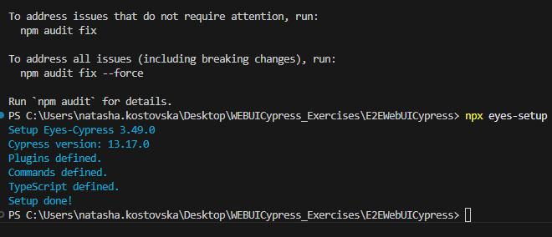

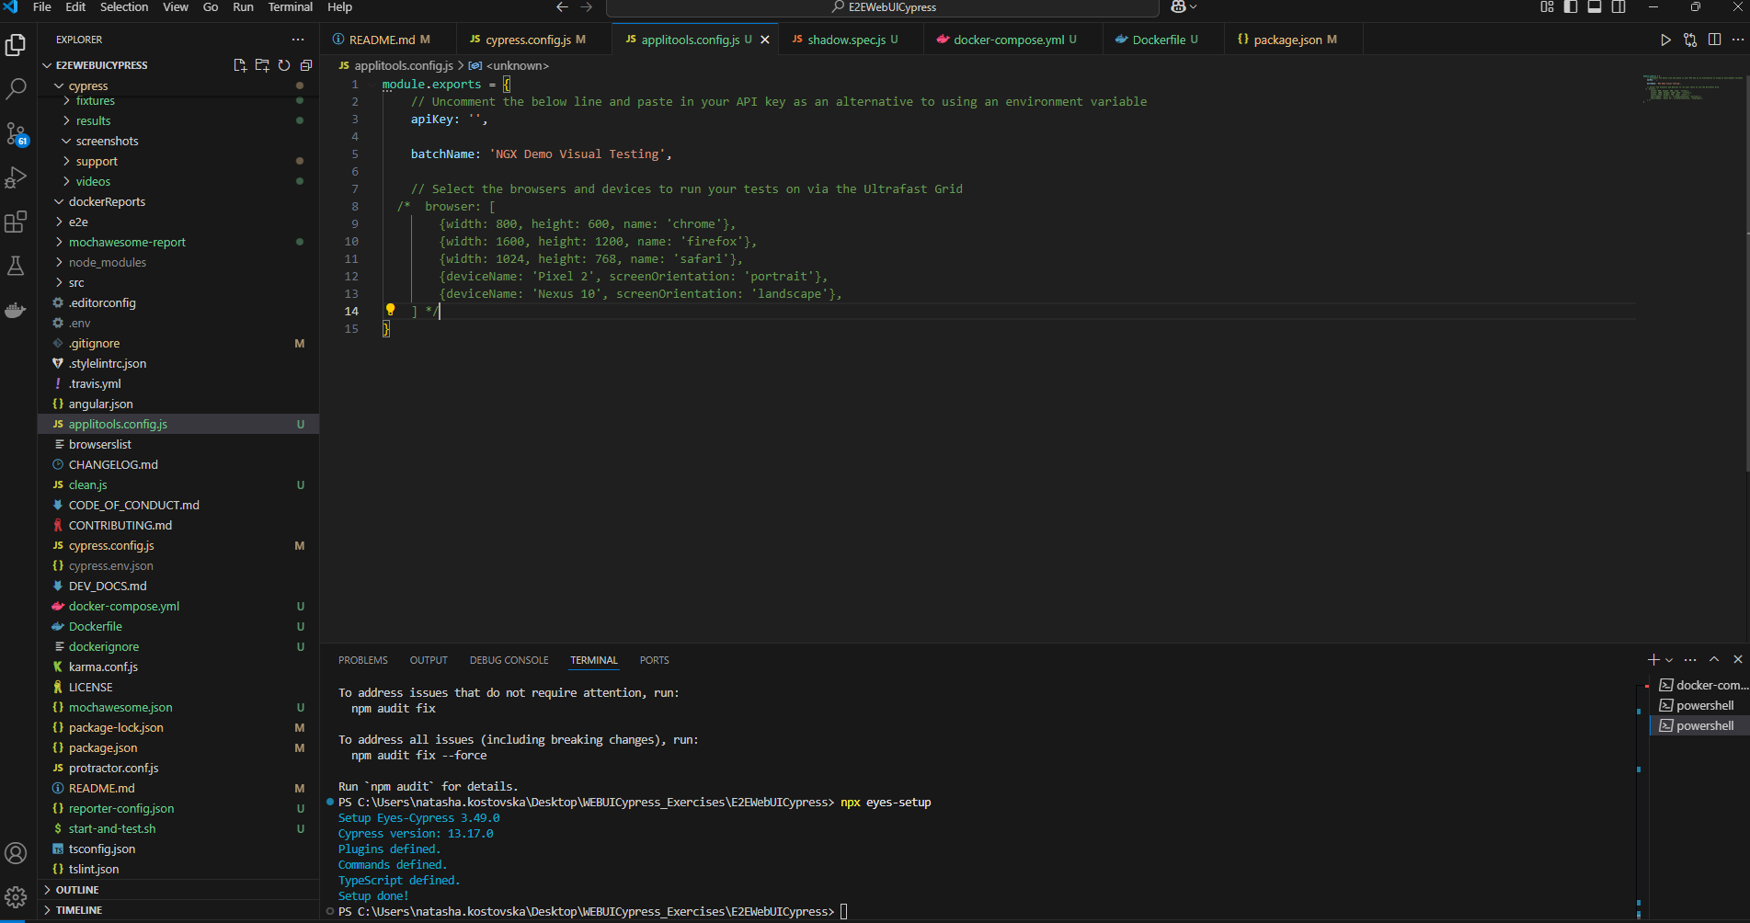

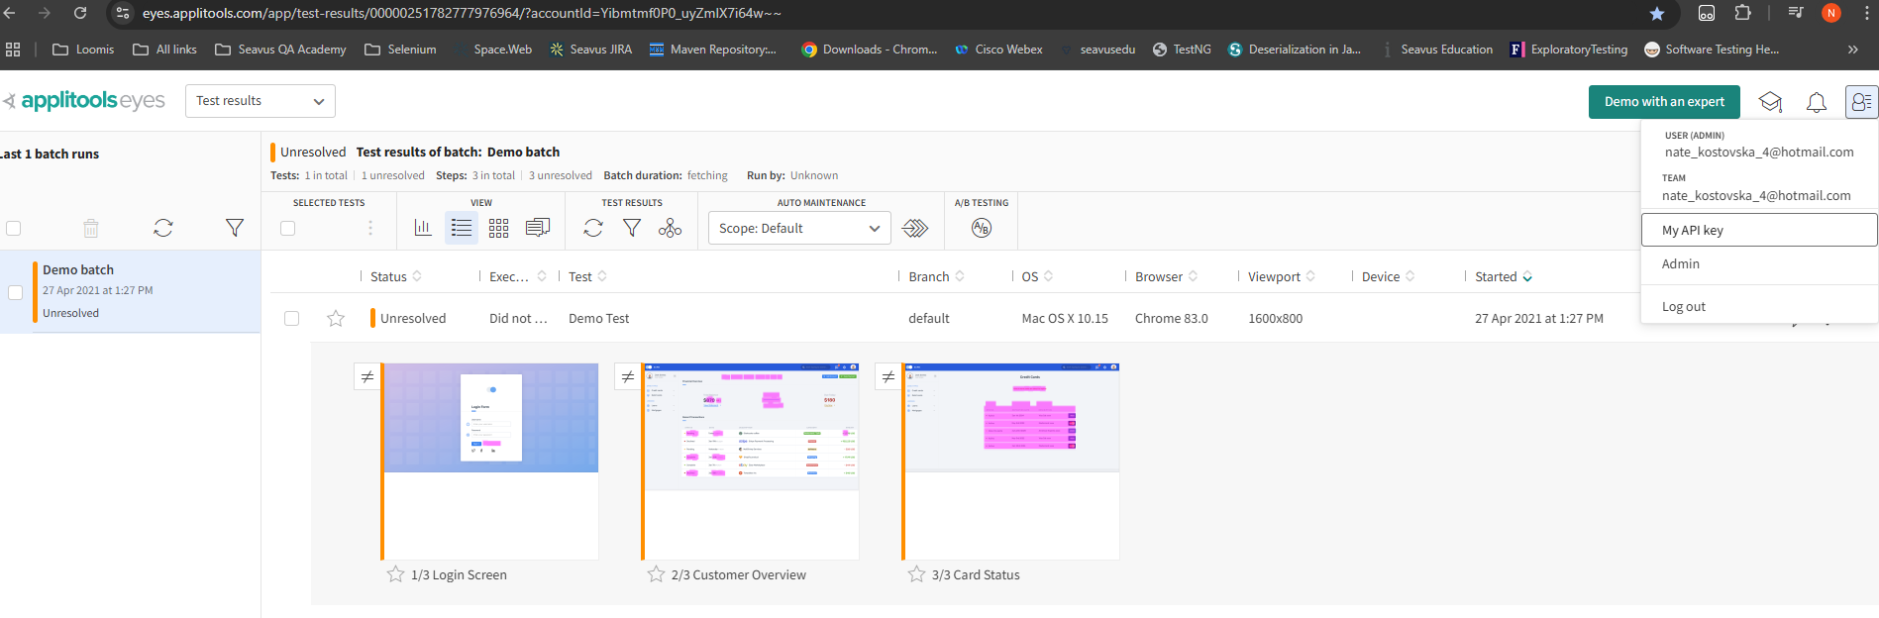

describe('visual testing', () => {

    beforeEach(() => {

        cy.eyesOpen({

            appName: 'NGX Cypress Test App',

            testName: Cypress.currentTest.title

        });

    });

    it('test eith applitools demo app', () => {

        cy.visit('/')

        cy.eyesCheckWindow({

            tag: 'Home Page'

        })

        navigateTo.formLayoutPage()

        cy.eyesCheckWindow({

            tag: 'Form Layouts'

        })

    })

    afterEach(() => {

        cy.eyesClose();

      })

})

module.exports = {

    // Uncomment the below line and paste in your API key as an alternative to using an environment variable

    apiKey: 'xKuWX3Fu105PNz431w2iJ5DTALo1074ErIS98l9c8OnwXWjY110',

    batchName: 'NGX Demo Visual Testing',

    // Select the browsers and devices to run your tests on via the Ultrafast Grid

  /*  browser: [

        {width: 800, height: 600, name: 'chrome'},

        {width: 1600, height: 1200, name: 'firefox'},

        {width: 1024, height: 768, name: 'safari'},

        {deviceName: 'Pixel 2', screenOrientation: 'portrait'},

        {deviceName: 'Nexus 10', screenOrientation: 'landscape'},

    ] */

}

cypress.env.json

.env